Head Start Birth to Five
2025 Annual Report
Floyd County Community Action Agency, Inc.

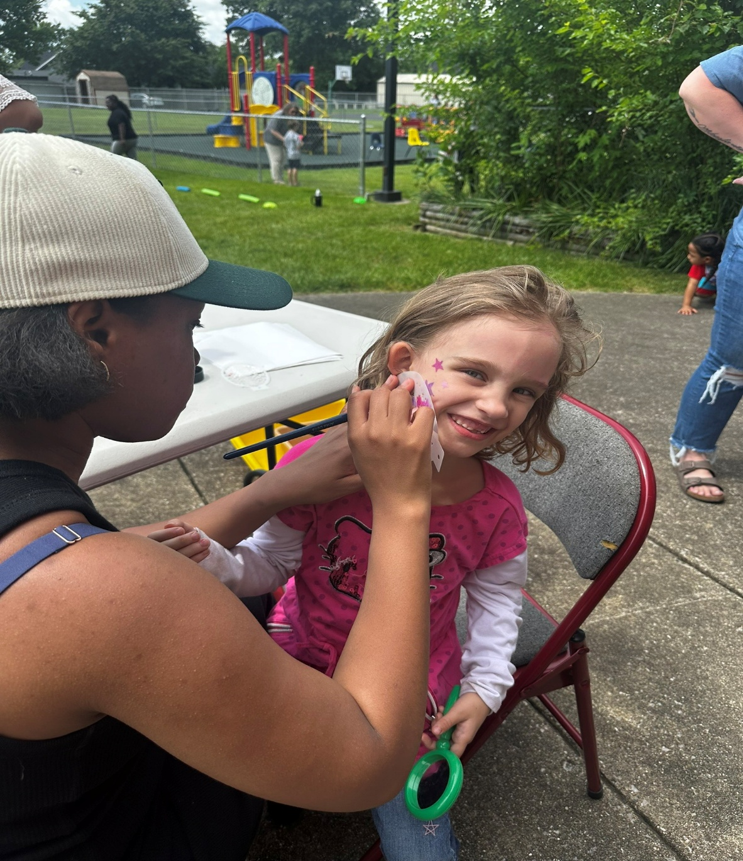


PURPOSE

Head Start began in 1965 under the Johnson Administration as part of the “War on Poverty.” Floyd County Head Start launched in 1971 serving three to five-year-old’s. FCHS promotes school readiness for preschool age children from low-income families by providing comprehensive services to children and families. Floyd County Head Start launched Early Head Start in 2019 serving birth to three-year-old’s too.
These services and programs include education, health and development screenings, health and safety, social and emotional health, nutrition, social services, transition services, and services for children with disabilities. These services are provided to support the mental, social, and emotional development of the child and their families.
ABOUT US
Floyd County Head Start Birth to Five provides Early Head Start and Head Start services for young children, families, and community stakeholders. Services include home visiting and center-based services for families with children birth to five.

MISSION
- Bringing staff, community, and families together to promote education, wellness, and self-sufficiency.

OUR VALUES
- Encourage a child’s natural curiousity
- Ensure a Teacher’s ability to understand that each child is unique
- Ensure Cultural Competency of all staff
- Parent’s are the child’s first and most important teacher

Community Assessment Summary

The 2025 Floyd County Head Start Birth to Five Community Assessment update reviewed the statistics of Floyd County residents in the areas of employment, education, child abuse and neglect, and health/nutrition.
FCCAA program goals are in conjunction with the five-year grant cycle; they are not changed only objectives can be updated. FCCAA, Inc. program goals include the following;
- All FCHS Birth to Five staff, students, and families are in a physically and emotionally safe learning environment.
- Promote Head Start Birth to Five and educate Floyd County agencies on the benefits of Head Start Birth to Five.
- All FCHS Birth to Five staff, students, and families will receive support and growth opportunities in professional development and instruction.

Our program goals correlate with the community’s priorities of;
- Meet the basic needs of community members, particularly the homeless and the mentally ill.
- Build a qualified work force to attract good jobs by supporting education and enrichment across the life course.
- Sustainably develop the economy to provide meaningful work and broadly shared economic security through living wage jobs and a clean and safe environment.

The 2025 Comprehensive Community Needs Assessment Update report identified the agency strengths and assets as (a) providing high quality services to local communities and (b) opportunities for employment for parents. This correlates with some of the community strengths including employment rates and job availability and overall medium income.

Challenges of Floyd County Community Action Agency, Inc. as (a) attracting qualified staff, (b) retaining staff/morale/mental health of staff, and (c) staffing completing their job responsibilities due to staff shortages.

  - Employee salary and benefits are inadequate with positions that require only a high school diploma. The recruitment of qualified staff, the organization needs to evaluate pay compared to local businesses as well as childcare and preschool level;
  - Retaining staff and increasing staff morale while being short staffed can be a challenge;
  - Staff completing their job responsibilities while covering other positions; supervisors covering classrooms, family advocates covering breaks, managers covering custodial positions, etc.

Program Goals

All FCHS staff, students, and families will receive support and growth opportunities in professional development and instruction.

Promote Head Start and educate Floyd County education and social services agencies on the benefits of Head Start.



All FCHS staff, students, and families are in a physically and emotionally safe learning environment.

Program Highlights

265 Families Served  We served 265 families during the 2024-2025 program year; 192 Head Start (age three to five) and 73 Early Head Start (prenatal to age three).  In our program, 14.7% were under income, 4.1% were foster families, 6.8% were homeless, and 69.2% were on public assistance. |  |   5  Teacher Assistants (1 Floater) maintained a Child Development Certificate.
17  Dual Language Learners | TRANSITIONS  89 Headed to Kindergarten    40 Transitioned to Head Start |     20%  of Staff are current/former  parents
91% Received Dental Exams    99% Received Medical Exams   |   Referrals to Community  Resources (196 Total Referrals)  62 Clothing Basic Needs 14 Transportation  33 Housing 11 Parenting  25 Employment 8 Education  22 Utilities 7 Mental Health  4 Food
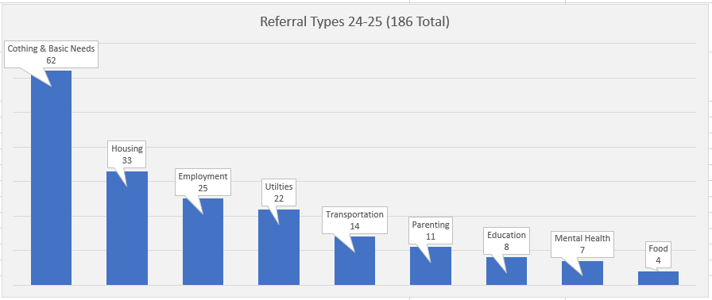
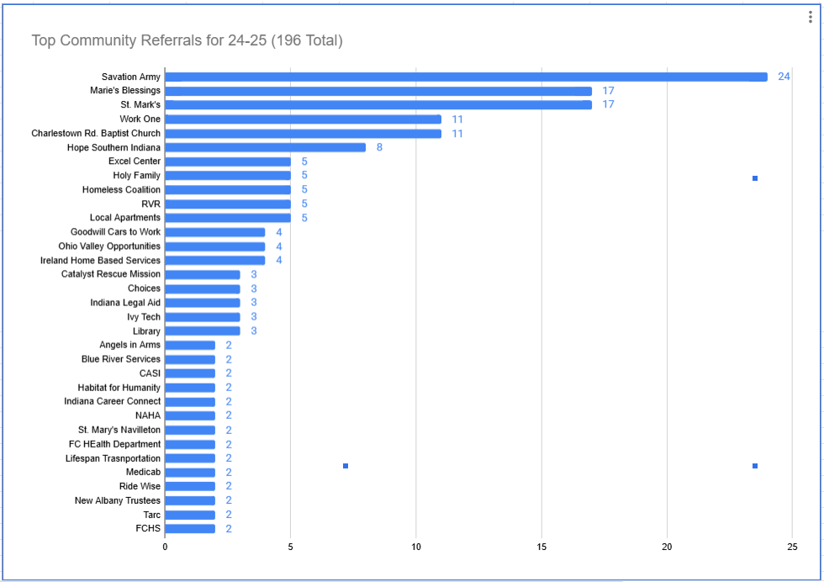
Program Data
Program Type | # Funded Enrollment | % Monthly Enrollment | % Monthly Attendance | Total # of Children Served
Early Head Start | 64 | 98% | 79% | 73
Head Start | 160 | 93% | 86% | 192
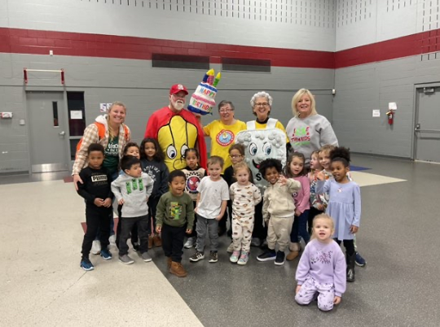
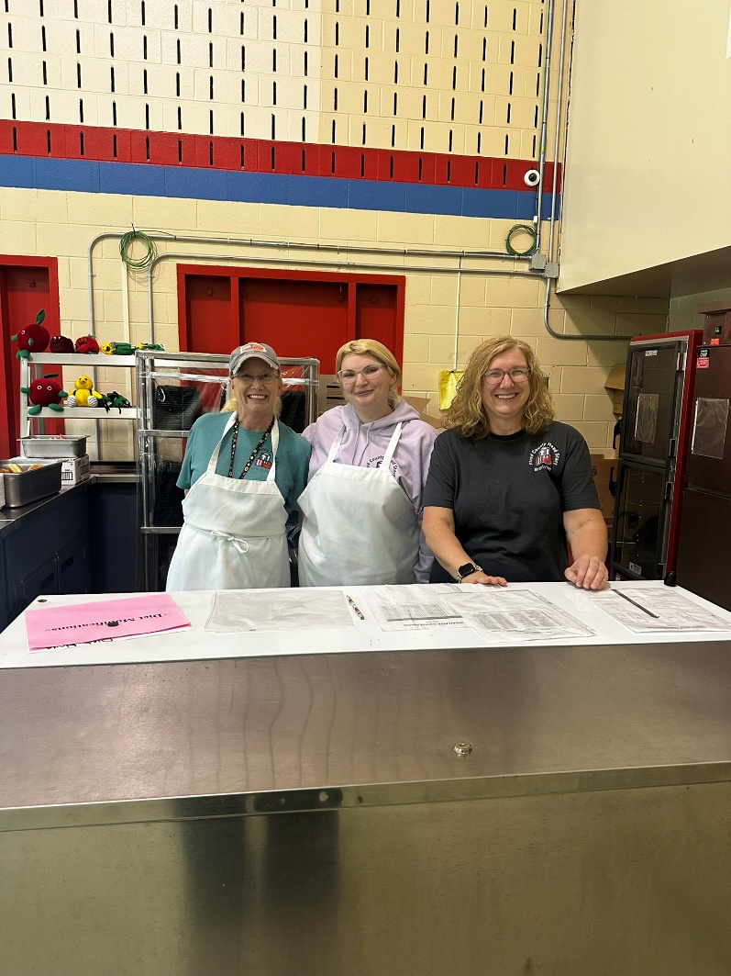
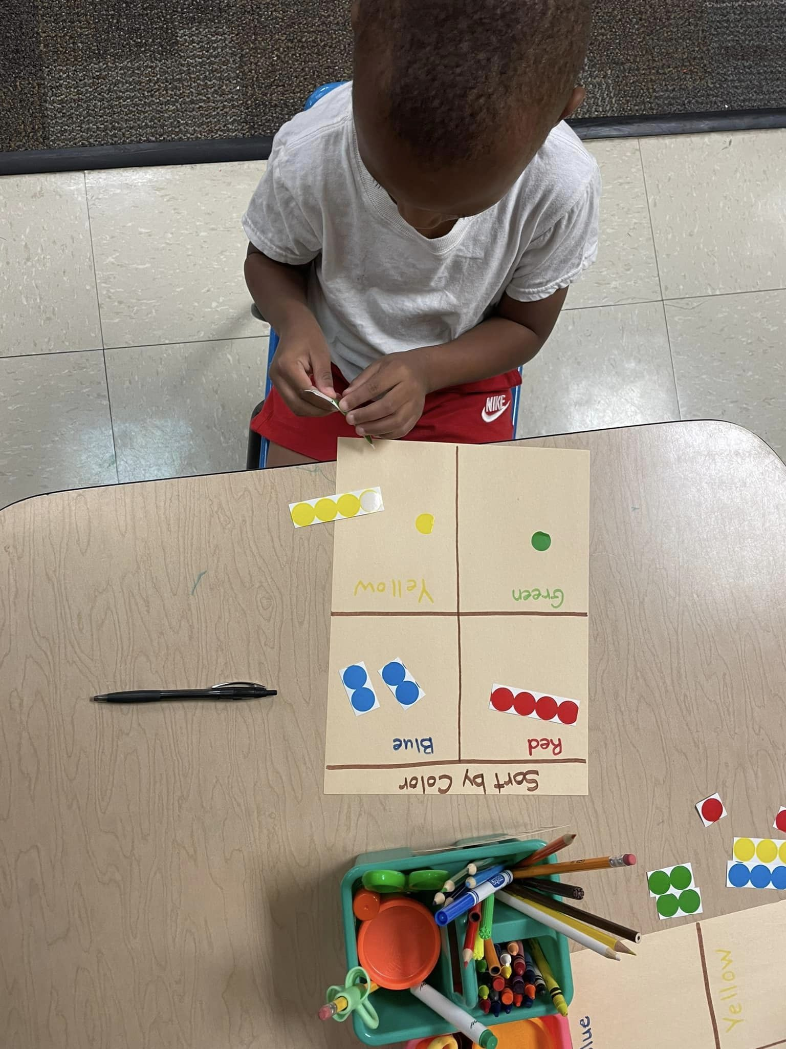
How do we encourage and support growth in the whole child?
Socially: Staff will set up the classroom environment to help children feel comfortable in school, trust their teachers, make friends, and feel they are a part of the group. Children will be encouraged to work out social issues with their peers, with teacher support.
​
Emotionally: To help children experience pride and self-confidence, develop independence and self-control, and have a positive attitude toward life. Staff will provide children with language naming emotions and provide the opportunity for them to use and understand them in the early childhood setting.
​
Cognitively: To help children become learners by letting them try out their ideas and experience success and by assisting them to learn to solve problems, ask questions, and use words to describe their thoughts, observations, and feelings.
Physically: To help children increase their large muscle skills and feel confident about what their bodies can do. Provide opportunities and activities that build the small muscles needed for building, stacking, and pre-writing.

Early Head Start: TPITOS Scores 2024-2025

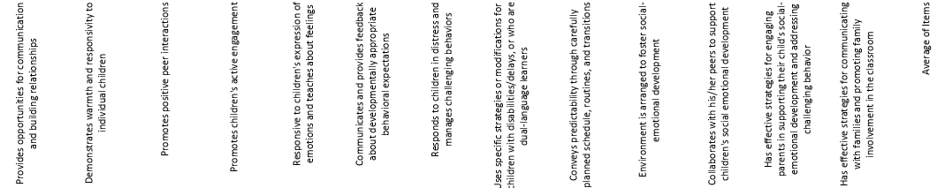

Head Start: TPOT Scores 2024-2025
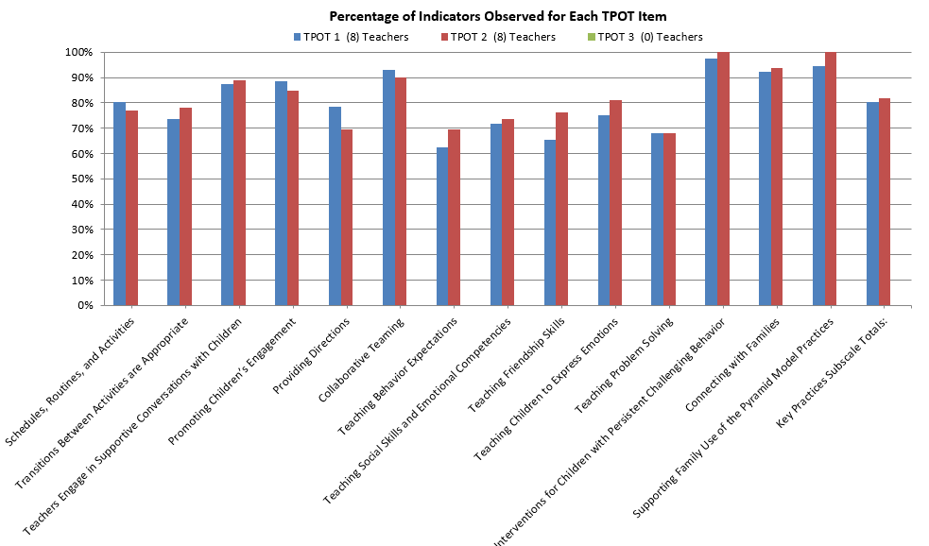

Head Start Birth to Five: 2024-2025 Child Outcomes
School Readiness Progress
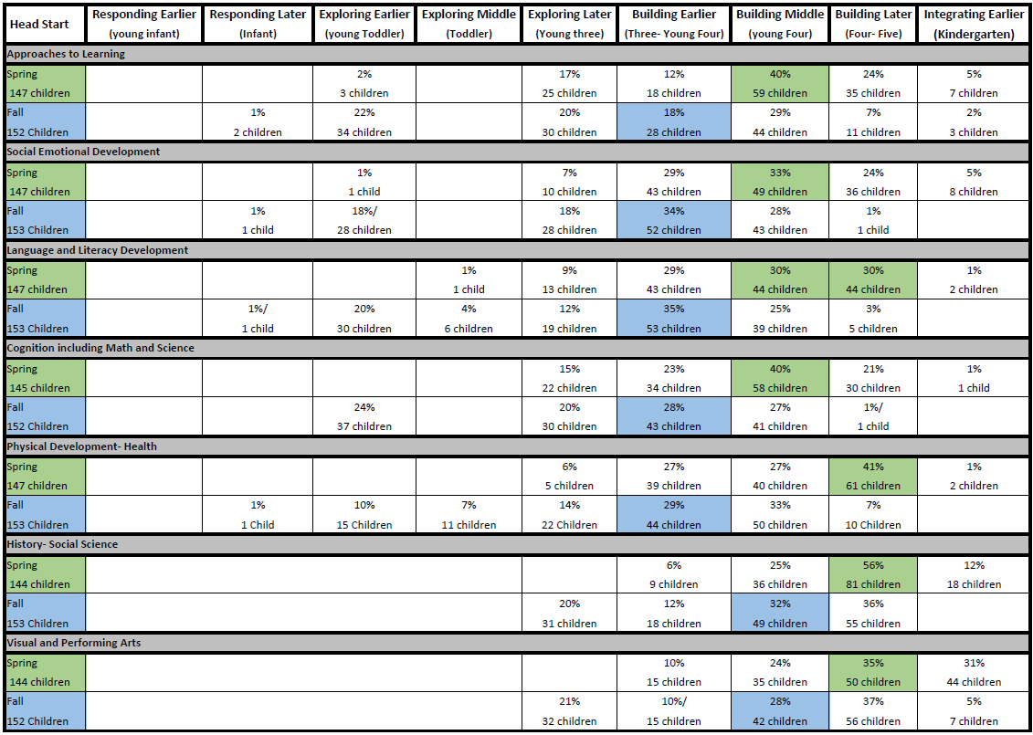
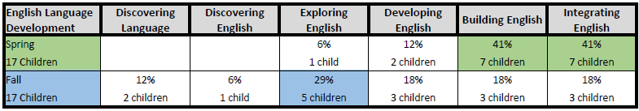

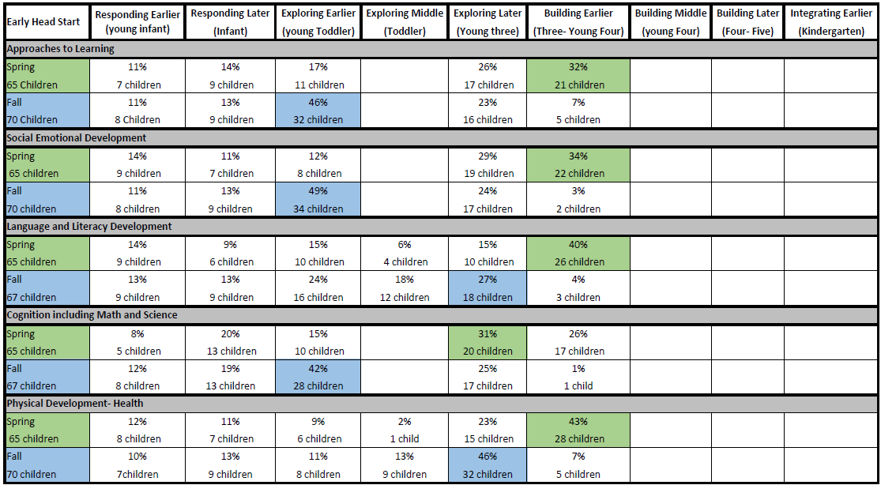

Family Engagement and Support
Head Start emphasizes the importance of the parent as the child’s first teacher; therefore, Family Engagement opportunities are vital within FCHS. We incorporate the Family and Community Engagement Framework into our Family School Readiness Plan to ensure a strong parents and community.
Head Start aims to support the entire family and to assist parents in their personal and family development. A strong, meaningful, and authentic relationship between a staff member and family is the cornerstone of an effective family partnership process. Family Services Staff work intensely with parents to create goals and to build their capacity as individuals and as families on their path to school readiness. The Head Start Program offers every family an opportunity to participate in a family assessment, discuss family's goals, and develop a family partnership agreement. The most important aspect of working with families is our ability to develop trusting relationships. This relationship allows each family to determine what they want to accomplish, how our staff can assist, and to what extent other community agencies will be involved. Parents are encouraged to focus on their strengths and priorities when developing Family Partnership Agreements (FPA). Our families participate in Family Fun Nights, Parent Meetings, Policy Council, and Parent Events throughout the school year to build relationships with their child and our staff.
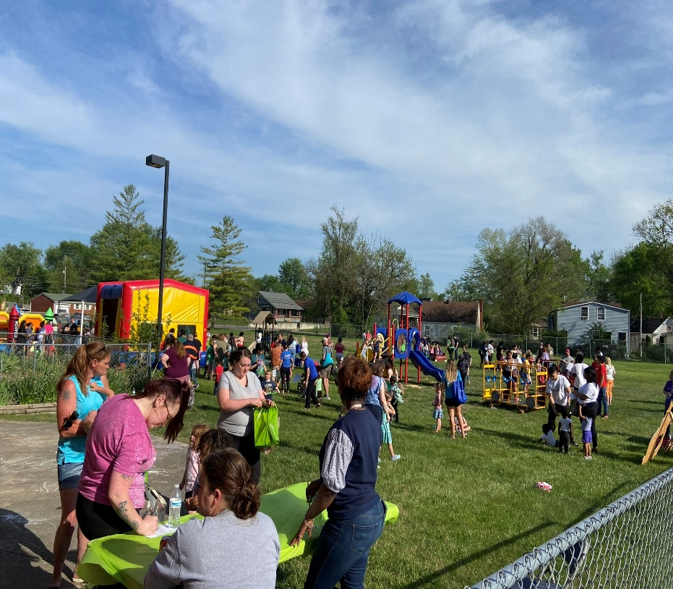

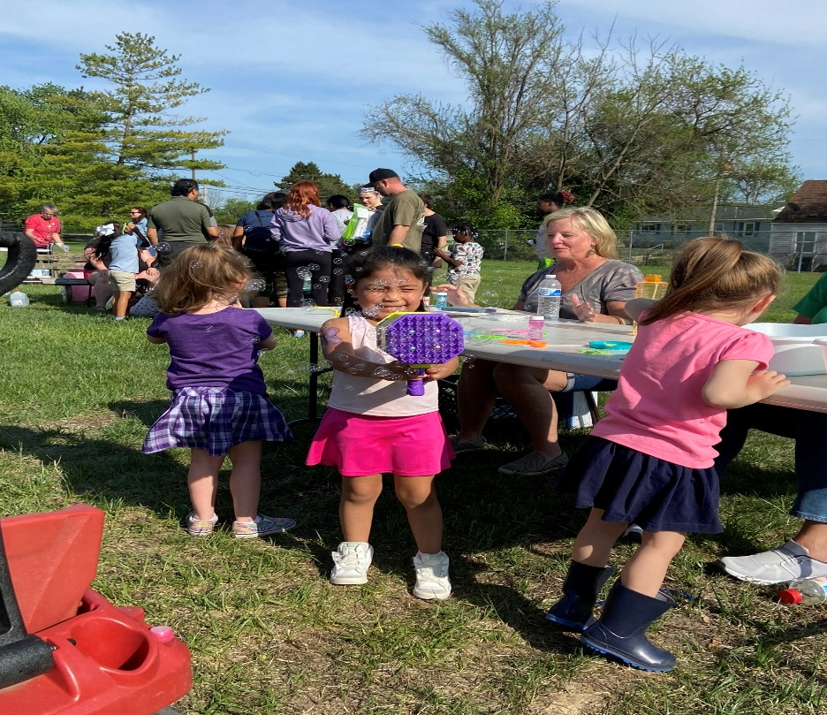

2024-2025 Fiscal Accountability
 | Head Start/Early Head Start
Expenses | Operating Budget | Actual Expenditures
Personnel | $3,037,814 | $ 3,122,786
Fringe | $626,266 | $ 594,539
Travel | $0 | $0
Equipment | $0 | $0
Supplies | $67,659 | $65,305
Contractual | $51,642 | $ 42,619
Construction | $0 | $0
Other | $484,220 | $ 637,286
Non-Federal Share | $1,057,488 | $ 790,547
Training & Technical Assistance | $60,337 | $ 45,915
CACFP | $213,320 | $ 147,067
Total | $5,598,746 | $ 5,446,063

As required by the Head Start Act §644(a)(2), we provide both our programmatic budget and expenditures as well as public and private funds received from each source. *FCCAA, Inc. does not receive any other funding. *Grant Year June 1, 2024 – May 31, 2025.

Audit Review

For Fiscal Year 2025, the Agency completed its required independent financial and Single Audit in accordance with Uniform Guidance. The audit resulted in an unmodified opinion on the financial statements, confirming they are presented fairly in all material respects. The compliance item noted during the audit was related to the timing of federal waiver processing outside of the Agency’s control. All required documentation had been properly submitted, and the matter does not reflect a deficiency in internal fiscal management. The Agency continues to maintain strong financial oversight, sound internal controls, and a commitment to responsible stewardship of federal funds.

Key Achievements

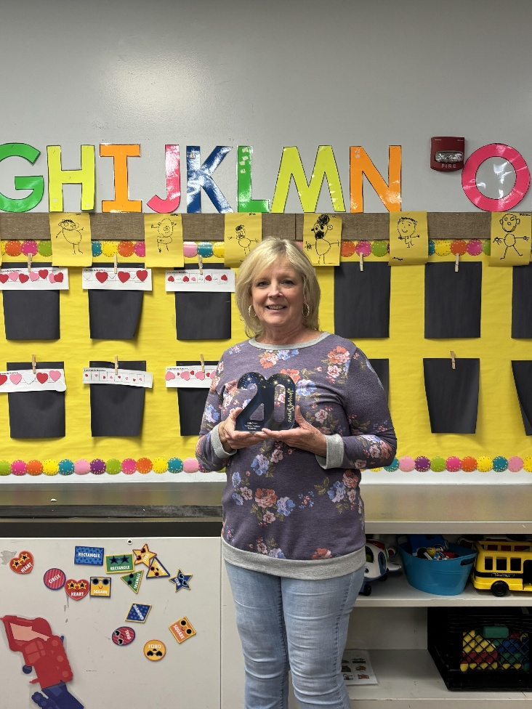
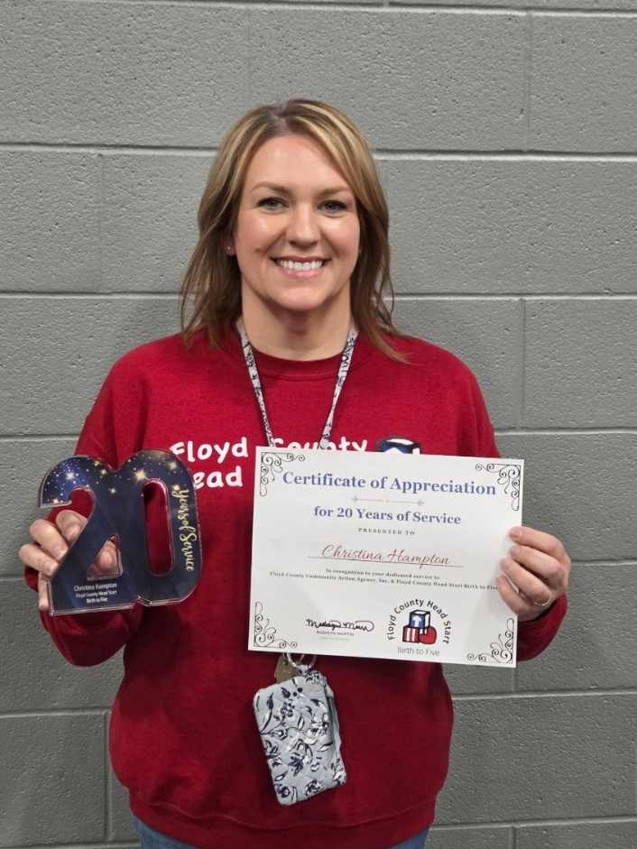

Christy Hampton 20 Years Laura Stone 20 Years

Staff Engagement/Wellness

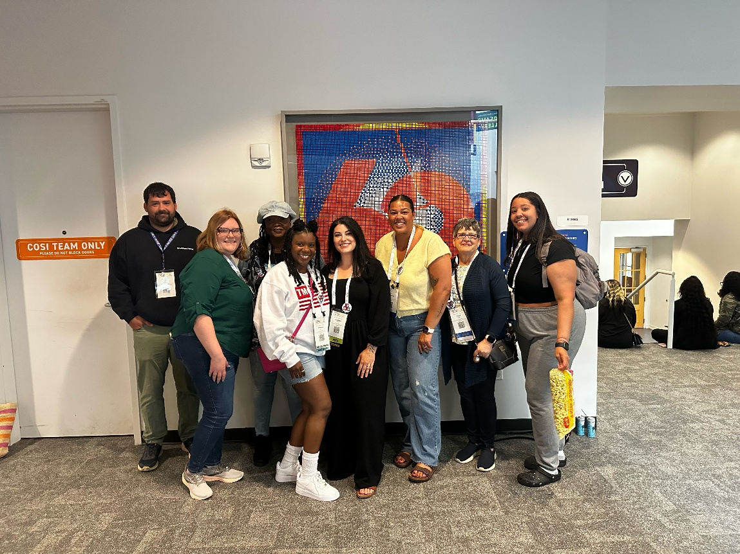
Our Agency remains deeply committed to cultivating a workplace culture that prioritizes professional growth, wellness, and meaningful engagement. We believe that when staff feel supported, valued, and equipped, the quality of services delivered to children and families is strengthened.
Throughout the year, team members participated in professional development opportunities both in-state and out-of-state, expanding their expertise in early childhood education, leadership, compliance, and program innovation. These experiences allow staff to bring best practices back to our community and ensure we remain aligned with evolving federal and state standards.
Employee wellness continues to be a priority. The Agency maintains an on-site staff fitness space to encourage physical health and stress management, recognizing the importance of caring for the whole person. In addition, we provide ongoing in-house mental health trainings focused on resilience, trauma-informed practices, stress management, and healthy workplace communication. These sessions support both personal wellbeing and professional effectiveness.
Financial literacy and stewardship are also embedded into our culture. Through our internal program, “The Beans,” staff receive practical, accessible education on fiscal management and program budgeting. This initiative strengthens organizational transparency and empowers team members to better understand how funding supports program operations and services.
Each year concludes with a comprehensive staff celebration that recognizes accomplishments, milestones, and collective impact. This event serves not only as recognition, but as an opportunity to reflect on shared successes and reinforce our mission-driven culture.
By investing in training, wellness, fiscal understanding, and recognition, the Agency continues to foster a strong, informed, and engaged workforce dedicated to serving children and families with excellence.

Leadership Team

Tara Wright, Director (Jun 24 – Dec 24)
Madisyn Martin, Director (Jan 25 – present)
Madisyn Martin, Chief Financial Officer
Donna Minton, Education Manager
Alex Stotts, Family Services Manager
Christy Hampton, Health Manager
Eric Bradshaw, Safety Compliance Manager

Governing Board/Policy Council

Board Officers
President: Dr. Teesue Fields, Retired Professor
Vice President: Mary Ann Bennett, Professor Ivy Tech
Treasurer: Matthew Brown, CPA, DMLO CPAs

Board Members
Amy Stein, Attorney, Stein Law Office
Brad Denman, New Washington Bank
Alicia Barnickle, Director Rauch, Inc.
Kelci Laporte, Early Intervention Coordinator, N.A.F.C. School Corp.
Mark Casper, Executive Director, St. Elizabeth’s Catholic Charities
Brandy Becker, Attorney, FC Deputy Prosecutor

Policy Council Officers
President: Jada Stewart

Policy Council Members
Robin Powell
Cortney Powell
Gina Johnson
Rikki Powell

Cathy Johnson, Professor IUS
Elaine Murphy, City Council At-Large

Children’s Academy Site
1111 Pearl Street
New Albany IN 47150
(812) 948-6981

 Thank you to Our Partners

