Floyd County Head Start Birth to Five

Floyd County Community Action Agency, Inc.

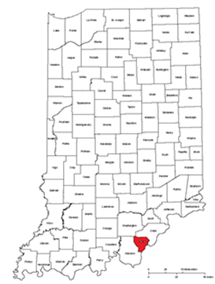

Community Assessment

2025

Table of Contents
Chapter 1: Introduction 3
Organizational Profile 3
Who We Are 4
Chapter 2: Key Data 5
Geography 5
General Population Characteristics 5
Target Population Characteristics 9
Income and Poverty 11
Housing 17
Foster Children 19
Child Abuse and Neglect 20
Children with Disabilities 21
Unemployment Rate 23
Chapter 3: Community Challenges 24
Healthcare 25
Preventable Hospital Events 36
Health Challenges 36
Dental Health 39
Mental Health 40
Nutrition 41
Physical Inactivity 49
Resource Availability/Accessibility 52
Use of Public Transportation 52
Child Care Resources 52
Chapter 4: Strengths & Challenges 54
Community Strengths and Challenges 54
Family Strengths & Challenges 55
Chapter 5: Conclusions 56
Needs, Goals and Takeaways 56

Chapter 1: Introduction

Organizational Profile

History
Head Start began in 1965 under the Johnson Administration as part of the “War on Poverty.” Floyd County Head Start launched in 1971. FCHS promotes school readiness for preschool age children from low-income families by providing comprehensive services to children and families. These services and programs include education, health and development screenings, health and safety, social and emotional health, nutrition, social services, transition services, and services for children with disabilities. These services are provided to support the mental, social, and emotional development of the child and their families.
Parents are the child's first and most important teacher. We strive to build relationships to provide support for positive parent-child interaction and family well-being.

Mission

Bringing staff, community, and families together to promote education, wellness, and self-sufficiency.

Core Values
- Encourage a child’s natural curiousity
- Ensure a Teacher’s ability to understand that each child is unique
- Ensure Cultural Competency of all staff
- Parent’s are the child’s first and most important teacher
- Ensure every child/family utilizes appropriate Health/Nutritional needs

Purpose

The 2024-2025 Community Needs Assessment for Floyd County Community Action Agency, Inc. is committed to the delivery of quality student services. The purpose of the community assessment is to provide an assessment of the needs and resources available to low-income families and priority child populations residing in the Floyd County service area. In other words, the report describes the context in which Head Start / Early Head Start Programs operate and is useful for ensuring that the correct services are provided to the appropriate population. The assessment paints a picture of the community and describes the diverse needs of families who may receive services. In addition, the community assessment covers the community's history, its economic and political scene, and its strengths and challenges.

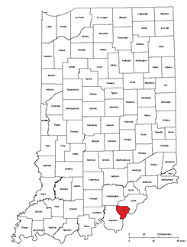
Who We Are
Floyd County Head Start Birth to Five provides a quality child development program, including individualized education, health and family services, in a centralized location for 224 families with children from birth to five years old. The program offers a center-based program for four days per week; full day programming. The learning environment helps children develop socially and academically in an age-appropriate atmosphere. The Floyd County Head Start Preschool Program has operated since 1971 and has offered Birth to Five Services since 2019.
The collection and analysis of information from multiple sources serves a critical function in program design and delivery systems. The communitywide strategic planning and needs assessment process serves to identify population characteristics and defines the target population to be served by the program. It identifies relevant demographic features of the area and recognizes existing programs that also serve the target population.
This community assessment process also provides relevant information about the needs and strengths of individuals, programs and areas of the community given both by agencies that serve this population and by the population itself. The information provided in this community assessment informs Floyd County Head Start’s strategic planning process.
The information gathered through these sources will serve as a basis for the design of the Floyd County Head Start and Early Head Start program which serves children and their families throughout Floyd County, Indiana.
Based in New Albany, Indiana, Floyd County Community Action Agency, Inc. has provided services to children and families for over 45 years. This Head Start and Early Head Start program is a federally-funded, comprehensive early childhood program which provides school readiness, health, transportation, and family support services. A state-licensed facility, the program serves all of the Floyd County area.

Chapter 2: Key Data

Geography
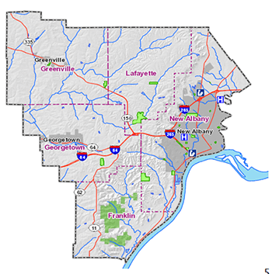
Floyd County is located in south eastern Indiana. Its county seat is New Albany. The population of the county was 79,594 as of the 2020 United States Census. Floyd County has the second-smallest land area in the entire state. It was formed in the year 1819 from neighboring Clark and Harrison counties.
Despite being classified as part of the Louisville/Jefferson County, KY–IN Metropolitan Statistical Area, the majority of the land area of Floyd County is rural
A total of 79,594 people live in the 148.48 square mile Floyd County area according to the U.S. Census Bureau American Community Survey 2017-21 5-year estimates.

Report Area | Total Population | Total Land Area (Square Miles) | Population Density (Per Square Mile)
Floyd County, | 79,594 | 148.48 | 536
Indiana | 6,751,340 | 35,826.17 | 188
United States | 329,725,481 | 3,533,041.03 | 93
Data Source: US Census Bureau, American Community Survey. 2017‐21.

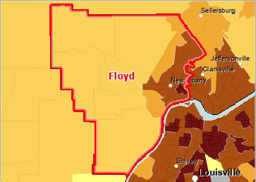
Population, Density (Persons per Sq Mile) by Tract, ACS 2017‐21
Over 5,000
1,001 ‐ 5,000
501 ‐ 1,000
51 ‐ 500
Under 51
No Data or Data Suppressed
Floyd County

General Population Characteristics
The population density for this area, estimated at 536 persons per square mile, is greater than the national average population density of 93 persons per square mile. It should be noted that the majority of the population live in the north eastern section of the county.

Total Population by Age Groups, Total
Looking at the percentage of age groups in relation to the state of Indiana, Floyd County has a higher percentage of residents over the age of 55 and a slightly lower percentage of children under the age of 17.
There are 4,537 children under the age of five in Floyd County and age eligible for our program.
 | Age 0‐4 | Age 5‐17 | Age 18‐24 | Age 25‐34 | Age 35‐44 | Age 45‐54 | Age 55‐64 | Age 65+
Floyd County, |  | 13,570 | 6,464 | 10,172 | 10,367 | 10,344 | 11,363 | 12,777
Indiana | 415,542 | 1,176,545 | 658,039 | 878,932 | 843,453 | 838,946 | 882,336 | 1,057,547
Data Source: US Census Bureau, American Community Survey. 2017‐21.
Report Area | Age 0‐4 | Age 5‐17 | Age 18‐24 | Age 25‐34 | Age 35‐44 | Age 45‐54 | Age 55‐64 | Age 65+
Floyd County | 5.70% | 17.05% | 8.12% | 12.78% | 13.02% | 13.00% | 14.28% | 16.05%
Indiana | 6.15% | 17.43% | 9.75% | 13.02% | 12.49% | 12.43% | 13.07% | 15.66%
United States | 5.89% | 16.62% | 9.20% | 13.76% | 12.87% | 12.63% | 12.99% | 16.04%
D US Census Bureau, American Community Survey. 2017‐21

Total Population by Race Alone
This indicator reports the total population of the report area by race.
Report Area | White | Black | Asian | Native American  Alaska Native | Native Hawaiian  Pacific Islander | Some Other Race | Multiple Races
Floyd County | 70,659 | 3,963 | 986 | 84 | 9 | 577 | 3,316
Indiana | 5,483,296 | 635,076 | 163,657 | 11,399 | 2,276 | 167,683 | 287,953
United States | 224,789,109 | 41,393,012 | 18,782,924 | 2,722,661 | 615,557 | 18,382,796 | 23,039,422
Data Source: US Census Bureau, American Community Survey. 2017‐21.


The table shows the racial breakdown by percentage. As can be observed, the service area is primarily white. It should be remembered that poverty does not strike proportionally across the races, but it is still expected that the majority of families being served by Floyd County Head Start/ Early Head Start will be white.

Data Source: US Census Bureau, American Community Survey. 2017‐21

Report  Area | White | Black | Asian | Native American or Alaska Native | Native Hawaiian or Pacific Islander | Some Other Race | Multiple Races
Floyd County | 88.77% | 4.98% | 1.24% | 0.11% | 0.01% | 0.72% | 4.17%
Indiana | 81.22% | 9.41% | 2.42% | 0.17% | 0.03% | 2.48% | 4.27%
United States | 68.17% | 12.55% | 5.70% | 0.83% | 0.19% | 5.58% | 6.99%
Data Source: US Census Bureau, American Community Survey. 2017‐21.

Hispanic Population
Report Area | Total Population | Hispanic or Latino Population | Hispanic or Latino Population, Percent | Non‐Hispanic Population | Non‐Hispanic population Percent
Floyd County | 79,594 | 2,856 | 3.59% | 76,738 | 96.41%
Indiana | 6,751,340 | 494,408 | 7.32% | 6,256,932 | 92.68%
United States | 329,725,481 | 60,806,969 | 18.44% | 268,918,512 | 81.56%
Data Source: US Census Bureau, American Community Survey. 2017‐21.
Although US Census data report that Floyd County has less than 4% of the population who identify as Hispanic, observations by staff indicate that the Hispanic population is growing in Floyd County. Given the small number reported by the census there is some divergence of census data and observations by staff. If program continues to serve Hispanic families this may indicate a growing need for bi-lingual staff.
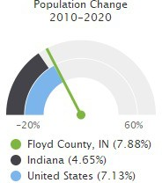

Total Population Change, 2010‐2020
According to the United States Census Bureau Decennial Census, between 2010 and 2020 the population in the report area grew by 5,880 persons, a change of 7.88%. This is significantly higher than the state of Indiana the population growth for the United States.

Report Area | Total Population, 2010 Census | Total Population, 2020 Census | Population Change, 2010‐2020 | Population Change, 2010‐2020, Percent
Floyd County, IN | 74,604 | 80,484 | 5,880 | 7.88%
Indiana | 6,483,799 | 6,785,528 | 301,729 | 4.65%
United States | 312,471,161 | 334,735,155 | 22,263,994 | 7.13%

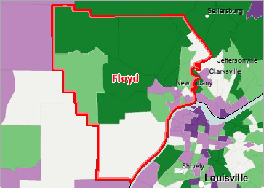
Population Change, Percent by Tract, US Census Bureau 2010 ‐ 2020
Over 10.0% Increase ( + )
2.0 ‐ 10.0% Increase ( + )
Less Than 2.0% Change (‐ )
2.0 ‐ 10.0% Decrease ( ‐ )
Over 10.0% Decrease ( ‐ )
No Population or No data
Floyd County, IN

Median Age
Of the estimated 79,594 total population in the report area, the median age of all persons is 39.7. This indicates that the report population as a whole generally trends older than the state, which has a median age of 37.9. These data are based on the latest U.S. Census Bureau American Community Survey 5‐year estimates.
Report Area | Total Population | Median Age
Floyd County, IN | 79,594 | 39.7
Indiana | 6,751,340 | 37.9
United States | 329,725,481 | 38.4
Data Source: US Census Bureau, American Community Survey. 2017‐21.
Median Age by Tract, ACS 2017‐21
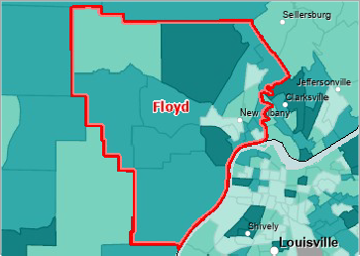
Over 45.0
40.1 ‐ 45.0
35.1 ‐ 40.0
Under 35.1
No Data or data suppressed
Floyd County, IN

Target Population Characteristics

Families with Children
According to the most recent American Community Survey estimates, 28.4% of all occupied households in Floyd County are family households with one or more child(ren) under the age of 18. As defined by the US Census Bureau, a family household is any housing unit in which the householder is living with one or more individuals related to him or her by birth, marriage, or adoption. It is notable that the rural areas of Floyd County have a higher percentage of families with children than the urban areas.
Report Area | Total Households | Total Family Households | Families with Children (Age 0‐17) | Families with Children (Age 0‐17), % of Total Households
Floyd County | 31,833 | 20,166 | 9,044 | 28.4%
Indiana | 2,622,601 | 1,688,696 | 792,324 | 30.21%
United States | 124,010,992 | 80,755,759 | 37,558,302 | 30.29%
Data Source: U.S. Census Bureau (2023). American Community Survey 1-year estimates.

Households with Children (Age 0‐17), Percent by Tract, ACS 2017‐21
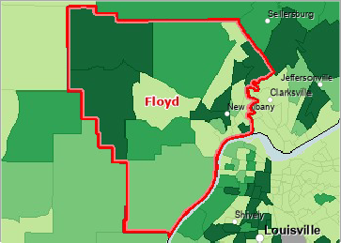
Over 35.0%
31.6 ‐ 35.0%
28.1 ‐ 31.5%
Under 28.1%
No Data or Data Suppressed
Floyd County, IN

Population Age 0‐4
Of the estimated 81,931 total population in the county, an estimated 4,242 are children under the age of 5, representing 5.18% of the population. These data are based on the latest U.S. Census Bureau American Community Survey 5‐year estimates.
The census tract map shows that the area with the highest percentage of children under the age of five are in the north western parts of the county. This is a rural area so the actual number of children may not be as high as the areas with more concentrated population.
Report Area | Total Population | Population Age 0‐4 | Percent Population Age 0‐4
Floyd County, IN | 81,931 | 4,242 | 5.7%
Indiana | 6,924,275 | 408,828 | 6.0 %
United States | 340,110,988 | 18,400,235 | 5.6%
Data Source: US Census Bureau, American Community Survey. 2017‐21.

Population Age 0‐4, Percent by Tract, ACS 2017‐21
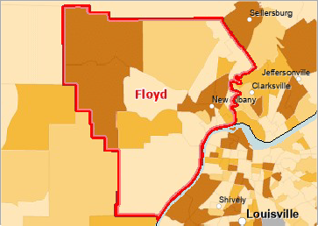
Over 7.0%
6.1 ‐ 7.0%
5.1 ‐ 6.0%
Under 5.1%
No Data or Data Suppressed

Population Age 0‐4 by Race
Report Area | Non-Hispanic White | Black or African American | Native American or Alaska Native | Asian | Native Hawaiian or Pacific Islander | Some Other Race | Multiple Race
Floyd County, IN | 3,747 | 270 | 0 | 45 | 0 | 33 | 442
Indiana | 307,515 | 45,869 | 445 | 10,336 | 37 | 13,037 | 38,303
United States | 11,751,883 | 2,656,473 | 176,042 | 1,011,688 | 41,428 | 1,304,593 | 2,481,014
Data Source: US Census Bureau, American Community Survey. 2017‐21.
The table shows the racial breakdown by percentage of population. As can be observed, the county is primarily white. It is expected that the majority of children being served by Floyd County Head Start/ Early Head Start will also be white.

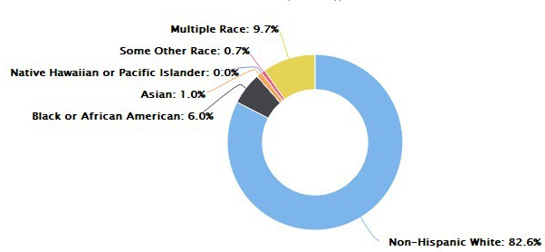
Estimates of Head Start Eligible Children
 | 2020 | 2021 | 2022 | 2023 | 2024
 | 5-Year-Olds | 4-Year-Olds | 3-Year-Olds | 2-Year-Olds | 1-Year-Olds
Floyd County Births | 806 | 808 | 865 | 865 | 760*
County Poverty Rate | .105 | .114 | .0949 | .0949 | .118
Low Income Children By Age | 85 | 92 | 82 | 82 | 90

Total Eligible 3-4 Year Olds | 216 |  | (.5)85+82+92= 259
Total Eligible 1-2 Year Olds | 172 |  | 82+90=172
TOTAL | 388
Head Start Eligible Children
Drop Rate |  | 20.8% (45 Kids)
On My Way Pre-K Services |  | 76 slots
NAFCS Pre-k Program |  | 80 slots
NAFCS Pre-K Early Intervention |  | 100 Slots Special Education Services Only
Early Head Start Eligible Children and Pregnant Women
Estimated Drop Rate |  | 12% (21 Kids) Center Based
Nurse Family Partnerships Services |  | 41 Slots (based on NFP Goodwill Report)
Healthy Families Services |  | 67 Slots (based on HF Report for active families)
*Estimation based on Indiana’s birth rates
There are an estimated 174 income eligible 3 and 4 year-olds in Floyd County, plus estimated half of the 5 year olds that are not yet age eligible for public schools, 42. That estimation is brought to 216 income eligible 3,4, and 5 year-olds. The table above indicates that there is a stability in numbers of Head Start income eligible children for the program.
While these projections show FCCCA, Inc. may be able to maintain enrollment, other considerations including drop rates and other preschool programs play a major factor in maintaining enrollment. For the 2023-2024 school year, the State of Indiana provided Floyd County with 76 slots for On My Way Pre-K services that are currently being provided to students via home-based daycares and the local school system. The local school system, New Albany Floyd County School Corporation, also obtained slots for elementary schools to offer preschool services; 80 slots in the elementary schools across the county in 2023-2024.
Head Start Averaged 157 kids for the last 6 months of this school year. Due to the abundance of 3 year-olds this was the maximum capacity for the Head Start classrooms since a classroom with a majority of 3 year-olds cannot exceed 17.

Income and Poverty

Income
Two common measures of income are Median Household Income and Per Capita Income. Based on American Community Survey 5-year estimates. Both measures are shown for Floyd County.

Report Area | Median Household Income | Per Capita Income
Floyd County | $69,858 | $34,961
Indiana | $61,944 | $32,537
United States | $69,021 | $37,638
Data Source: US Census Bureau, American Community Survey. 2017‐2021
Per Capita Income by County, ACS 2016‐20
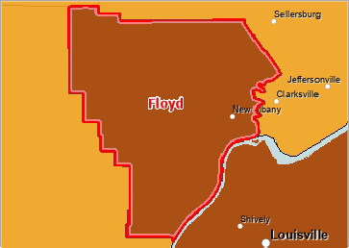
Over $30,000
$25,001 ‐ $30,000
$20,001 ‐ $25,000
Under $20,001
No Data or Data Suppressed Floyd County

Household Income
Median annual household income in the report area for 2024 are shown in the table below.
Report Area | Estimated Population | Median Household Income
Floyd County | 80,512 | $78,179
Indiana | 6,924,275 | $69,458
United States | 341,145,670 | $83,730
Data Source: US Census Bureau, Small Area Income and Poverty Estimates. 2024.

Median Household Income by County, SAIPE 2021
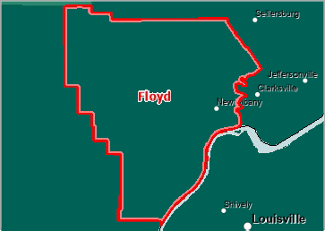
Over $60,000
$50,001 ‐ $60,000
$40,001 ‐ $50,000
Under $40,000
Floyd County

In both indicators, Per Capita Income and Household Income, Floyd County is higher in both than the state but lower than the United States’ income levels. One must remember these indicators report median income. The median is calculated by taking the “middle” value, the value for which half of the observations are larger and half are smaller.

Poverty
When looking at the number of individuals in poverty in Floyd County one immediately notes that Floyd County is measurably lower in poverty than the state of Indiana. This holds true even when one looks only at poverty in children under the age of 18: the poverty rate reflects that Floyd County’s rates are not catastrophic or all pervasive.
The actual number of individuals in poverty, however, is constantly changing especially among young families. Employment status can change, marital status and household structure can change, and, in an area where many jobs are in the service area, number of hours worked can change.

Poverty ‐ Population Below 100% FPL
Poverty is considered a key driver of quality of life.
Within Floyd County 9.49% or 7,401 individuals for whom poverty status is determined are living in households with income below the Federal Poverty Level (FPL). This indicator is relevant because poverty creates barriers including access to health services, healthy food, adequate housing, and other necessities.
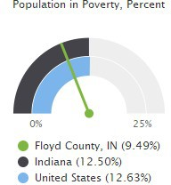
(Note: The total population measurements for poverty reports are lower, as poverty data collection does not include people in group quarters.)
Report Area | Total Population | Population in Poverty | Population in Poverty, Percent
Floyd County | 77,992 | 7,401 | 9.49%
Indiana | 6,550,921 | 819,005 | 12.50%
United States | 321,897,703 | 40,661,636 | 12.63%
Note: This indicator is compared to the state average.
Data Source: US Census Bureau, American Community Survey. 2017‐21.

Population Below the Poverty Level, Percent by Tract, ACS 2017‐21

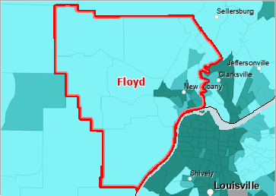
Over 20.0%
15.1 ‐ 20.0%
10.1 ‐ 15.0%
Under 10.1%
No Data or Data Suppressed
Floyd County

Poverty is highest in the central eastern portion of Floyd County. This is the New Albany area and surrounding communities. This is also the area with the highest concentration of population, the highest population of minority individuals, and the youngest population in age. All of these factors indicate a need for Head Start and Early Head Start services in this area.

Poverty ‐ Children Below 100% of the FPL
In Floyd County 14.40% or 2,558 children aged 0‐17 are living in households with income below the Federal Poverty Level (FPL).
Report Area | Total Population | Population < Age 18 | Population < Age 18 in Poverty | Population < Age 18 in Poverty, Percent
Floyd County | 77,992 | 17,758 | 2,558 | 14.40%
Indiana | 6,550,921 | 1,555,165 | 261,181 | 16.79%
United States | 321,897,703 | 72,996,065 | 12,443,424 | 17.05%
Data Source: US Census Bureau, American Community Survey. 2017‐21.
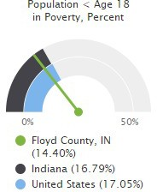
Using these data to calculate the number of age-eligible children, county-wide for the Program, 2,959 children are age-eligible for Early Head Start and 1,973 are age-eligible for Head Start. These children are located mainly in the south eastern sector of the county.
Note: This indicator is compared to the state average.

Population Below the Poverty Level, Children (Age 0‐17), Percent by Tract, ACS 2017‐21
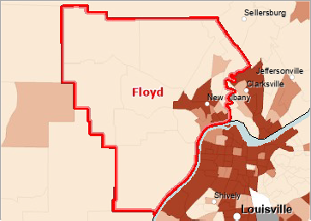
Over 30.0%
22.6 ‐ 30.0%
15.1 ‐ 22.5%
Under 15.1%
No Population Age 0‐17 Reported
No Data or Data Suppressed Floyd County, IN

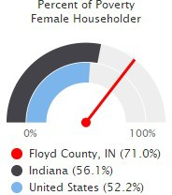
Family Poverty Rate by Family Type
The percentage of households in poverty by household type are shown for the report area. It is estimated that 7.0% of all households were living in poverty within the report area, compared to the national average of 8.9%. Of the households in poverty, female headed households represented 71.0% of all households in poverty, compared to 22.8% and 6.2% of households headed by males and married couples, respectively. It can be concluded that the program will be serving a large number of single, female householders.
Note: This indicator is compared to the state average

Report Area | Poverty Rate All Types | Percent of Poverty Married Couples | Percent of Poverty Male Householder | Percent of Poverty Female Householder
Floyd County, IN | 7.0% | 22.8% | 6.2% | 71.0%
Indiana | 8.6% | 31.8% | 12.1% | 56.1%
United States | 8.9% | 37.0% | 10.8% | 52.2%
Data Source: US Census Bureau, American Community Survey. 2017‐21.

Single Parent Family Households Living Below the Poverty Level, Percent by Tract, ACS 2017‐21
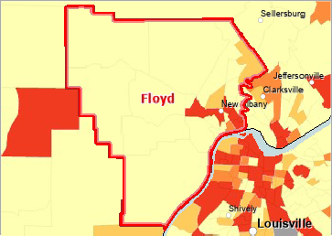
Over 37.0%
30.1 ‐ 37.0%
23.1 ‐ 30.0%
Under 23.1%
No 1 Parent Households Reported
No Data or Data Suppressed Floyd County, IN

Households Receiving SNAP by Poverty Status (ACS)
Since families receiving SNAP benefits are eligible for Head Start and Early Head Start regardless of income, it is important to look at how many families in Floyd County are SNAP recipients and where they are located. These data on the table below shows that according to the American Community Survey (ACS), 2,231 households (or 7.40%) received SNAP payments during 2017‐2021. During this same period there were 1,547 households with income levels below the poverty level that were not receiving SNAP payments.

Report Area | House-holds Receiving SNAP  Total | House-holds Receiving SNAP  % | House-holds Receiving SNAP  Income Below Poverty | House-holds Receiving SNAP  Income Above Poverty | House-holds Not Receiving SNAP  Total | House-holds Not Receiving SNAP  Percent | House-holds Not Receiving SNAP  Income  Below  Poverty | House-holds Not Receiving SNAP  Income Above  Poverty
Floyd County, IN | 2,231 | 7.40% | 1,344 | 887 | 27,906 | 92.60% | 1,547 | 26,359
Indiana | 236,989 | 9.04% | 121,516 | 115,473 | 2,385,612 | 90.96% | 200,535 | 2,185,077
United States | 14,105,231 | 11.37% | 6,300,621 | 7,804,610 | 109,905,761 | 88.63% | 9,081,147 | 100,824,614
Data Source: US Census Bureau, American Community Survey. 2017‐21
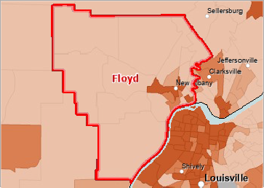
Households Receiving SNAP Benefits Percent by Tract, ACS 2017‐21
Over 19.0%
14.1 ‐ 19.0%
9.1 ‐ 14.0%
Under 9.1%
No Data or Data Suppressed
Floyd County

Poverty ‐ Children Eligible for Free/Reduced Price Lunch
Free or reduced-price lunches are served to qualifying students in families with income between under 185 percent (reduced price) or under 130 percent (free lunch) of the US federal poverty threshold as part of the federal National School Lunch Program (NSLP).
According to the most recent data for 2023-2024, out of 11,380 total public-school students in the report area, 4,165 were eligible for the free or reduced-price lunch program in the latest report year. This represents 36.6% of public-school students, which is lower than the state average of 44.4%.
Note: States with more than 80% records "not reported" are suppressed for all geographic areas, including hospital service area, census tract, zip code, school district, county, state, etc.
Note: This indicator is compared to the state average.
Report Area | Total Students | Students Eligible for Free or  Reduced-Price Lunch | Students Eligible for Free or  Reduced-Price Lunch, Percent
Floyd County | 11,380 | 4,165 | 36.6%
Indiana | 1,033,897 | 456,776 | 44.4%
United States | 40,249,650 | 19,533,765 | 51.7%

Data Source: National Center for Education Statistics, NCES ‐ Common Core of Data. 2023‐2024.
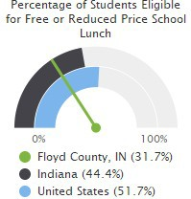
Despite having a lower percentage of public-school children eligible for free or reduced lunch, the percentage is still substantial. Although Head Start and Early Head Start children are automatically eligible for the free lunch program while enrolled in Head Start, these numbers show the large percentage of children throughout the community with eligibility for this program.

Housing

Housing Quality ‐ Substandard Housing and Availability of Affordable Housing

A large number of Hoosiers are forced into overcrowded, poorly maintained, or geographically undesirable housing due to lack of options, contributing to what's often termed "substandard" conditions. In essence, while not a direct count of dilapidated homes, the overwhelming lack of affordable options means thousands of Indiana residents are likely living in substandard situations out of necessity. In Indiana, only 38 rental homes are affordable and available for every 100 extremely low-income households. Indiana needs to make 137,000 more homes affordable for extremely low-income households by expanding access to rental assistance and building deeply affordable rental homes.

Floyd County population has grown from 55,622 in 1970 to 80,842 in 2024. It is a predominately white county 86%, Black and African American residents 6% and all other racial groups make up the last 7 to 8%. Floyd County had a large number of public housing that had been built in the 1940’s and 1950’s. This county also had more than a third of rental units had been built pre-1960. Between 2018 and 2022 many of the oldest public housing units have been eliminated in Floyd County.

This reports the number and percentage of owner‐ and renter‐occupied housing units having at least one of the following conditions: 1) lacking complete plumbing facilities, 2) lacking complete kitchen facilities, 3) with 1 or more occupants per room, 4) selected monthly owner costs as a percentage of household income greater than 30%, and 5) gross rent as a percentage of household income greater than 30%. Selected conditions provide information in assessing the quality of the housing inventory and its occupants. This data is used to easily identify homes where the quality of living and housing can be considered substandard. Of the 30,137 total occupied housing units in Floyd County, 6,178 or 20.50% have one or more substandard conditions. Program staff will have information and resources for enrolled families who live in sub-standard housing. This was exacerbated by the fact that many of the public housing facilities in Floyd County have been closed and families must seek out their own low-income housing.
Note: This indicator is compared to the state average.
Data Source: US Census Bureau, American Community Survey. 2017‐21.

Substandard Housing Units, Percent of Total by Tract, ACS 2017‐21
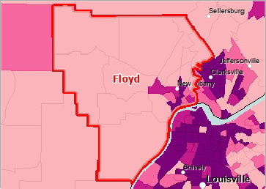
Over 34.0%
28.1 ‐ 34.0%
22.1 ‐ 28.0%
Under 22.1%
No Data or Data Suppressed
Floyd County, IN

Homeless Children & Youth
This indicator reports the number of homeless children and youth enrolled in the public school system during the school year 2022-2023. According to the data source definitions, homelessness is defined as lacking a fixed, regular, and adequate nighttime residence. Those who are homeless may be sharing the housing of other persons, living in motels, hotels, or camping grounds, in emergency transitional shelters, or may be unsheltered. Data are aggregated to the report‐area level based on school‐district summaries where three or more homeless children are counted.
In Floyd County, of all the 11,702 students enrolled in reported districts during the school year 2022-2023, there were 144 or 1.2% homeless students, which is lower than the statewide rate of 1.78%.
However, within the program for 2024-2025, 6.5% of the Head Start enrollment and 5.7% of Early Head Start was identified as children experiencing homelessness. This significantly higher number of children experience is attributable to the fact that young families are often sharing housing, living with other families and/or reside in housing that meets the definition of homeless (camper trailers, campgrounds, etc.).
Note: Data are available for 100.00% school districts in Floyd County, representing 100.00% of the public school student population.
Report Area | Students in Reported Districts | Homeless Students | Homeless Students, Percent
Floyd County, IN | 11,702 | 144 | 1.2%
Indiana | 983,653 | 16,427 | 1.67%
United States | 49,090,607 | 1,374,537 | 2.8%

Data Source: Kids Count Data Center, Indiana Youth Institute. 2023. NCES Statistics 2023.

FCCAA, Inc. Birth to Five Homeless Rates
School Year | # of Homeless Children | Percentage
2019-2020 | 13 | 3.8%
2020-2021 | 15 | 6.2%
2021-2022 | 19 | 7%
2022-2023 | 21 | 8%
2023-2024 | 11 | 3.7%
2024-2025 | 19 | 6.8%

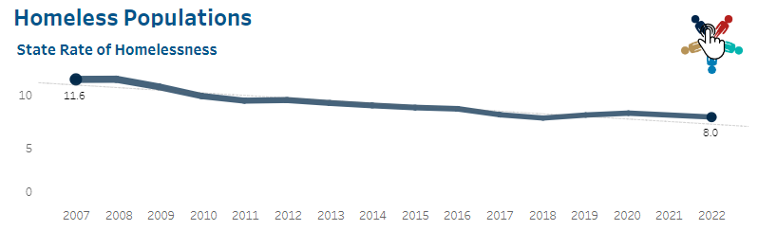
Indiana rate of 8.8 per 1,000. Totaling 5449 people.

Foster Children
In 2021, 203,770 children under 18 entered foster care in the United States, a rate of 3 per 1,000. The rate of entry has hovered at 3 or 4 per 1,000 for two decades. Kids ages 1 to 5 make up the largest share (29% in 2021) of children entering care. National data also show that Black and American Indian and Alaska Native children continue to be overrepresented among those entering foster care. In 2021, Black children represented 20% of those entering care but only 14% of the total child population, while American Indian and Alaska Native kids made up 2% of those entering care and 1% of the child population. The reasons for this are complex, and efforts to improve racial equity in child welfare have been underway for many years.
Indiana is home to nearly 31,000 children in foster care and has the fourth-highest rate of youth in foster care in the nation; Indiana has a rate of 5 per 1,000.. Floyd County schools identify slightly less that 2 percent of children as being in foster care. Floyd County Head Start and Early Head Start saw a total of 17 foster children during the 2023-2024 program year 7.5% of families. The number of children not being cared for by their parents is much higher since these numbers do not reflect the “informal” foster care system: family members raising absent family members’ children without going through the Indiana Department of Children’s Services. This number was an additional 9.3% for 2023-2024.
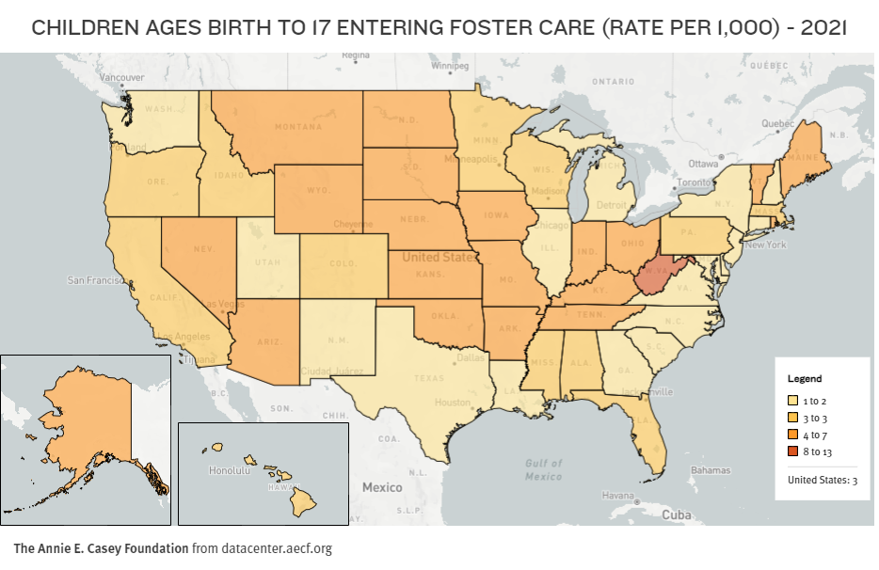

Child Abuse and Neglect
The likelihood that a child will be abused or neglected in the United States has improved slightly in recent years: 8 in every 1,000 kids under 18 were confirmed victims of maltreatment in 2020 and 2021, after holding steady at 9 per 1,000 from 2015 to 2019. Of approximately 585,000 victims in 2021, three in four experienced neglect, consistently the most common type of maltreatment. About 1 in 6 (16%) of these children were physically abused, 10% were sexually abused, 6% were emotionally abused and 2% experienced medical neglect. Young kids are the most at risk, as 70% of verified victims were 10 and under in 2021, similar to previous years.
As of 2021, Indiana averages 13.6 children per 1,000 are child maltreatment victims; 49.8% of those children being under the age of five years old. Indiana has a significantly higher percentage of child maltreatment victims.
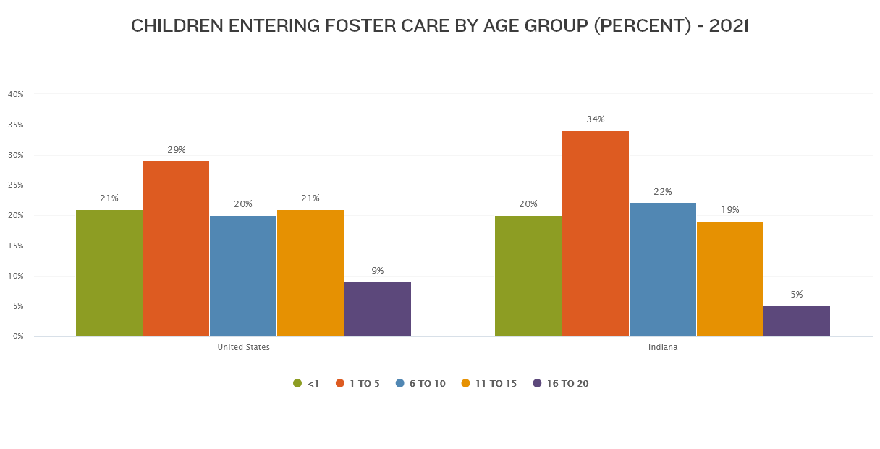
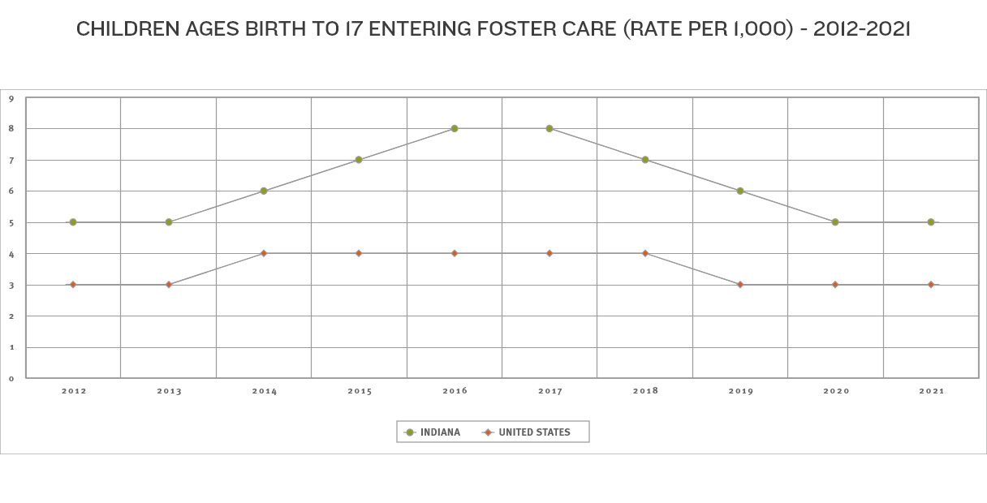

Children with Disabilities
As of April 1, 2024, Indiana reported the following numbers of children with disabilities enrolled in special education programs:
- For ages 5 through 22 (school-age children), the total unduplicated count was 182,252.
- For preschool-aged children (ages 3 to 5), the total unduplicated count was 17,348.
These counts include children with a range of disabilities, such as autism spectrum disorder, specific learning disabilities, developmental delays, and other health impairments. The numbers are based on official data collected by the Indiana Department of Education and reflect students receiving special education services in Indiana schools as of the most recent reporting period in 2024.
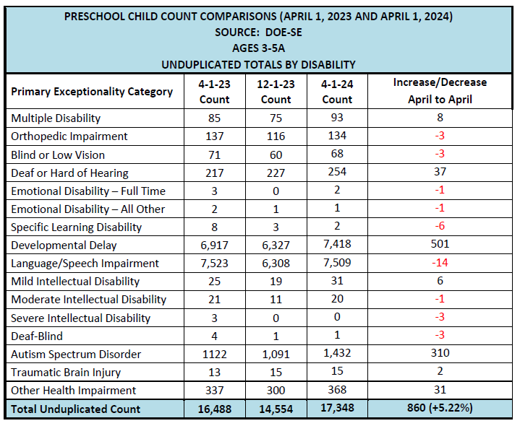
Services for children with disabilities at an early age is critical for their development. Floyd County Head Start and Early Head Start actively recruits and enrolls children with disabilities: for the 2024-2025 school year 36.8% of Head Start and 38.5% of Early Head Start were children with IEPs and IFSPs.
Disability | 2021-2022 | 2022-2023 | 2023-2024 | 2024-2025
Speech/Language | 31 | 33 | 29 | 29
Developmental | 26 | 21 | 25 | 42
Autism | 0 | 0 | 0 | 0
Emotional Behavior | 0 | 0 | 0 | 0
Health | 3 | 4 | 6 | 1
Open Concerns | 5 | 0 | 5 | 1
Totals | 65(24%) | 58(28%) | *65 (36%) | 73 (28%)
*Includes data through 2/20/2024. Well above prior years and the year is not complete.
As can be seen on the combined data chart above, the program children with health/development disabilities and children with speech/language disabilities: this is consistent with other programs nationwide. For children under the age of five, diagnosticians use the “development delay” and/or “speech/language delay” to access service without having to pinpoint a more specific learning issue.
The rate of disabilities does not coincide with the rates of disabilities within the Head Start Birth to Five program. FCCAA, INC. works diligently with the LEA to ensure the needs of the students are being met. NAFCS (LEA) classrooms for children with special needs is 100% children with special needs due to the increase in numbers; they have removed all “typical” children from that program.

Unemployment Rate

Floyd County is part of Economic Growth Region 10, which had an unemployment rate of 3.6% in August 2025.
INDIANAPOLIS (September 19, 2025) - The unemployment rate of the State of Indiana in August was recorded to be 3.6% according to the Indiana Department of Workforce Development. By comparison, the national unemployment rate reported for August was 4.3%.
In addition, Indiana’s labor force participation rate is 63.6% compared to the national rate of 62.3%. This rate is the percentage of Hoosiers 16 and older that are either working or actively looking for work. Those not in the labor force include, primarily, students, retirees and other non-working populations, such as individuals unable to work due to a disability or illness, or adults responsible for their family's childcare needs. Indiana’s total labor force stands at 3,489,209.
August 2025 total private employment is 2,856,500 an increase of 3,900 from the previous month.
Industries that experienced job increases this month included:
- Trade, Transportation & Health Services (+2,400)
- Private Educational & Health Services (+1,700)
- Leisure & Hospitality (+1,300)
- Construction (+700)
As of September 1, 2025, there were 84,420 open job postings throughout the state. As of the week ending on September 6, 2025, Indiana had 19,393 continued unemployment insurance claims filed.
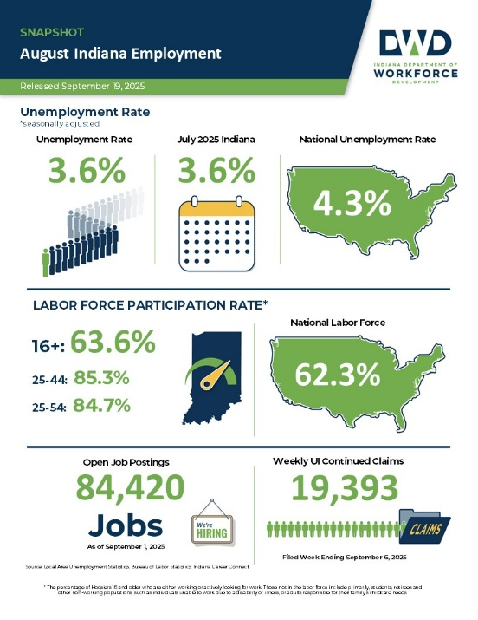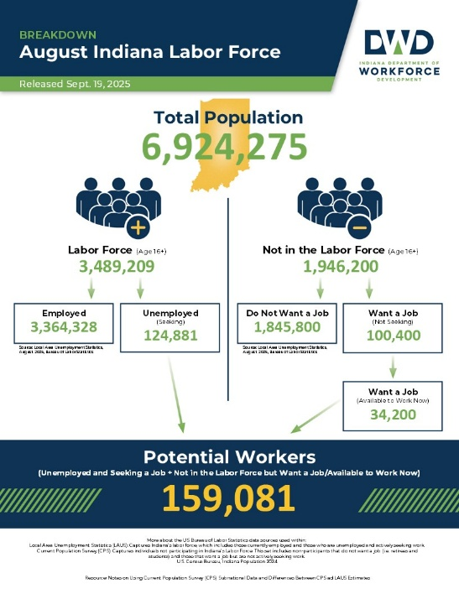

Chapter 3: Community Challenges

Healthcare

A lack of access to care presents barriers to good health. The supply and accessibility of facilities and physicians, the rate of non-insured, Rates of morbidity financial hardship, transportation barriers, cultural competency, and coverage limitations affect access, mortality, and emergency hospitalizations can be reduced if community residents access services such as health screenings, routine tests, and vaccinations. Prevention indicators can call attention to a lack of access or knowledge regarding one or more health issues and can inform program interventions.

Insurance Population Receiving Medicaid
This indicator reports the percentage of the population with insurance enrolled in Medicaid (or other means-tested public health insurance). This indicator is relevant because it assesses vulnerable populations which are more likely to have multiple health access, health status, and social support needs; when combined with poverty data, providers can use this measure to identify gaps in eligibility and enrollment.

Data Source: https://www.in.gov/fssa/ompp/medicaid-enrollment-dashboard | Percent of Insured Population Receiving Medicaid  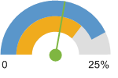  Floyd County, IN (19.5%)  Indiana (29%)  United States (23%)
  Report Area | Total Population  (For Whom Insurance Status is Determined) | Population with Any Health Insurance | Population Receiving Medicaid | Percent of Insured Population Receiving Medicaid
  Floyd County, IN | 75,281 | 68,490 | 16,454 | 19.5%
  Indiana | 6,920,000 | 3,460,000 | 1,769,576 | 29%
  United States | 305,200,000 | 276,875,891 | 77,200,000 | 23%

Population Receiving Medicaid by Age Group, Percent
Report Area | Under Age 18 | Age 18 - 64 | Age 65
Floyd County, IN | 42% | 48% | 10%
Indiana | 43% | 49% | 8%
United States | 41% | 17% | 9.8%
Insurance - Uninsured Children
The lack of health insurance is considered a key driver of health status. This indicator reports the percentage of children under age 19 without health insurance coverage. This indicator is relevant because lack of insurance is a primary barrier to healthcare access including regular primary care, specialty care, and other health services that contributes to poor health status.
Data Source: US Census Bureau, Small Area Health Insurance Estimates. 2014. Source geography: County | Percent Population Under Age 19 Without Medical Insurance  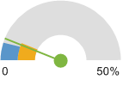  Floyd County, IN (5.98%)  Indiana (6.91%)  United States (5.05%)
  Report Area | Total Population Under Age 19 | Population with Medical Insurance | Percent Population With Medical Insurance | Population Without Medical Insurance | Percent Population Without Medical Insurance
  Floyd County, IN | 18,441 | 17,338 | 94.02% | 1,103 | 5.98%
  Indiana | 1,624,186 | 1,511,975 | 93.09% | 112,211 | 6.91%
  United States | 76,217,025 | 72,369,595 | 94.95% | 3,847,430 | 5.05%

Uninsured Population Under Age 18, Percent by Year, 2010 through 2015
Report Area | 2010 | 2011 | 2012 | 2013 | 2014 | 2015
Floyd County, IN | 16.1% | 17% | 16.6% | 16% | 14.20% | 9.9%
Indiana | 20.28% | 20.04% | 19.91% | 19.35% | 16.64% | 13.13%
United States | 21.52% | 21.11% | 20.76% | 20.44% | 16.37% | 13.21%

Access to Dentists
This indicator reports the number of dentists per 100,000 population. This indicator includes all dentists - qualified as having a doctorate in dental surgery (D.D.S.) or dental medicine (D.M.D.), who are licensed by the state to practice dentistry and who are practicing within the scope of that license.
Data Source: https://www.census.gov/popclock/world | Dentists, Rate per 100,000 Pop.  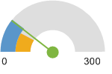  Floyd County, IN (63.82)  Indiana (52.8)  United States (65.6)
  Report Area | Total Population, 2024 | Dentists, 2024 | Dentists, Rate per population
  Floyd County, IN | 81,931 | 46 | 1780:1
  Indiana | 6,924,275 | 4,254 | 1470:1
  United States | 342,954,620 | 210,832 | 65.6

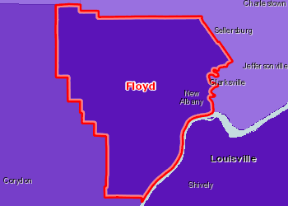 | Access to Dentists, Rate per 100,000 Pop. by County, AHRF 2015  Over 50.0  35.1 - 50.0  20.1 - 35.0  Under 20.1  No Dentists  Report Area

Access to Mental Health Providers
This indicator reports the rate of the county population to the number of mental health providers including psychiatrists, psychologists, clinical social workers, and counsellors that specialize in mental health care.
Data Source: University of Wisconsin Population Health Institute, County Health Rankings. 2018. Source geography: County | Mental Health Care Provider Rate (Per 100,000 Population)  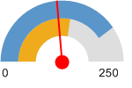  Floyd County, IN (118.1)  Indiana (140.5)  United States (202.8)
  Report Area | Estimated Population | Number of Mental Health Providers | Ratio of Mental Health Providers to Population | Mental Health Care Provider Rate (Per 100,000 Population)
  Floyd County, IN | 76,181 | 90 | 846.5 | 118.1
  Indiana | 6,588,521 | 9,263 | 711.3 | 140.5
  United States | 317,105,555 | 643,219 | 493 | 202.8

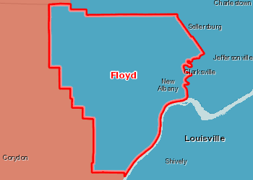 | Access to Mental Health Care Providers, Rank by County, CHR 2018  1st Quartile (Top 25%)  2nd Quartile  3rd Quartile  4th Quartile (Bottom 25%)  Bottom Quintile (Rhode Island Only)  No Data or Data Suppressed; -1  Report Area

Access to Primary Care
This indicator reports the number of primary care physicians per 100,000 population. Doctors classified as "primary care physicians" by the AMA include: General Family Medicine MDs and DOs, General Practice MDs and DOs, General Internal Medicine MDs and General Pediatrics MDs. Physicians age 75 and over and physicians practicing sub-specialties within the listed specialties are excluded. This indicator is relevant because a shortage of health professionals contributes to access and health status issues.
Data Source: US Department of Health Human Services, Health Resources and Services Administration, Area Health Resource File. 2014. Source geography: County | Primary Care Physicians, Rate per 100,000 Pop.  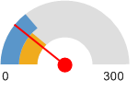  Floyd County, IN (64.32)  Indiana (75.9)  United States (87.8)
  Report Area | Total Population, 2014 | Primary Care Physicians, 2014 | Primary Care Physicians, Rate per 100,000 Pop.
  Floyd County, IN | 76,179 | 49 | 64.32
  Indiana | 6,596,855 | 5,005 | 75.9
  United States | 318,857,056 | 279,871 | 87.8

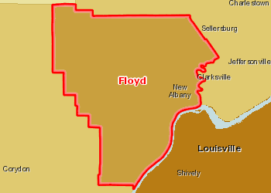 | Access to Primary Care Physicians, Rate per 100,000 Pop. by County, AHRF 2014  Over 80.0  60.1 - 80.0  40.1 - 60.0  Under 40.1  No Primary Care Physicians or No Data  Report Area

Dental Care Utilization
This indicator reports the percentage of adults aged 18 and older who self-report that they have not visited a dentist, dental hygienist or dental clinic within the past year. This indicator is relevant because engaging in preventive behaviors decreases the likelihood of developing future health problems. This indicator can also highlight a lack of access to preventive care, a lack of health knowledge, insufficient provider outreach, and/or social barriers preventing utilization of services.
Data Source: Centers for Disease Control and Prevention, Behavioral Risk Factor Surveillance System. Additional data analysis by CARES. 2006-10. Source geography: County | Percent Adults Without Recent Dental Exam  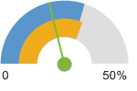  Floyd County, IN (21.1%)  Indiana (31.6%)  United States (30.2%)
  Report Area | Total Population  (Age 18 ) | Total Adults Without Recent Dental Exam | Percent Adults with No Dental Exam
  Floyd County, IN | 55,628 | 11,722 | 21.1%
  Indiana | 4,848,923 | 1,533,404 | 31.6%
  United States | 235,375,690 | 70,965,788 | 30.2%

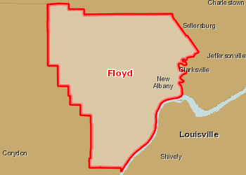 | Adults Age 18 Without Dental Exam in Past 12 Months, Percent by County, BRFSS 2006-10  Over 42.0%  34.1 - 42.0%  26.1 - 34.0%  Under 26.1%  No Data or Data Suppressed  Report Area

High Blood Pressure Management
In the report area, 34.7% of adults, or 19,280, self-reported that they are not taking medication for their high blood pressure according to the CDC's Behavioral Risk Factor Surveillance System (2006-2010). This indicator is relevant because engaging in preventive behaviors decreases the likelihood of developing future health problems. When considered with other indicators of poor health, this indicator can also highlight a lack of access to preventive care, a lack of health knowledge, insufficient provider outreach, and/or social barriers preventing utilization of services.

Data Source: Centers for Disease Control and Prevention, Behavioral Risk Factor Surveillance System. Additional data analysis by CARES. 2006-10. Source geography: County | Percent Adults with High Blood Pressure Not Taking Medication  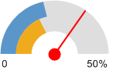  Floyd County, IN (34.7%)  Indiana (18.7%)  United States (21.7%)
  Report Area | Total Population  (Age 18 ) | Total Adults Not Taking Blood Pressure Medication (When Needed) | Percent Adults Not Taking Medication
  Floyd County, IN | 55,628 | 19,280 | 34.7%
  Indiana | 4,848,923 | 904,717 | 18.7%
  United States | 235,375,690 | 51,175,402 | 21.7%

STD Trends

To increase the efficiencies and support transforming data into action, CDC’s National Notifiable Disease Surveillance System (NNDSS) is migrating to the one CDC Data Platform(1CDP). Because of this, CDC has postponed the reconciliation and publication of 2024 NNDSS case surveillance data to allow state health departments and CDC more time to on-board to 1CDP. Therefore, state data may not have been reported during this transition. Sexually Transmitted Infections Surveillance 2024, Provisional Report Current Trends
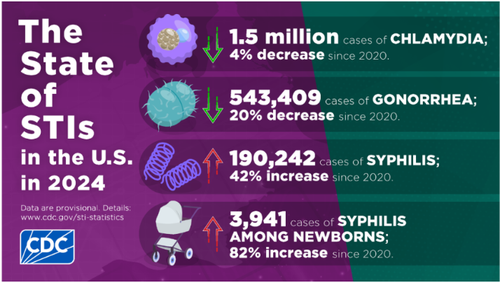

2024 Indiana Fast Facts ·
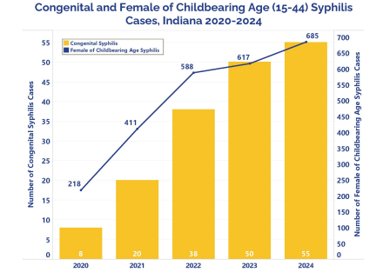
- 31,511 chlamydia cases at a rate of 455.1, 5.5% decrease in past five years
- 8,601 gonorrhea cases at a rate of 124.2, 39.4% decrease in the past five years
- 2,323 syphilis cases at a rate of 33.5, 73% increase over the past five years
- Cases of syphilis among women have increased 216% in the past five years
- 55 congenital syphilis cases reported, 10% increase compared to 2023
- Congenital syphilis cases have increased 588% in the past five years
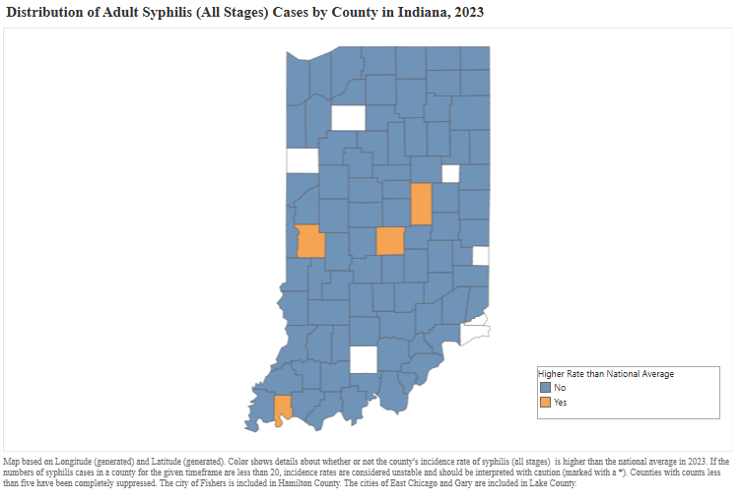
Data Source: Indiana Department of Health, STIs In Indiana, 2024 Executive Summary Report
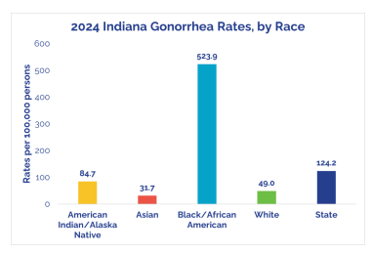

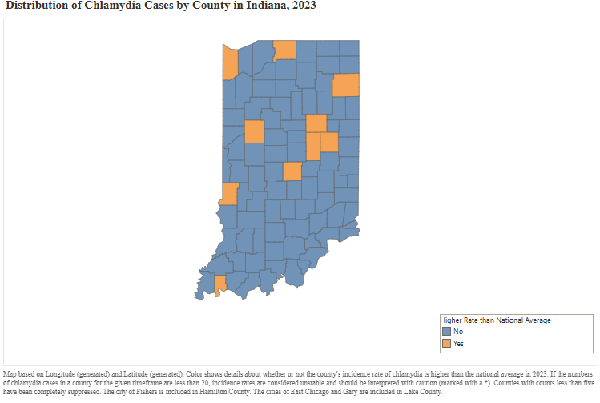
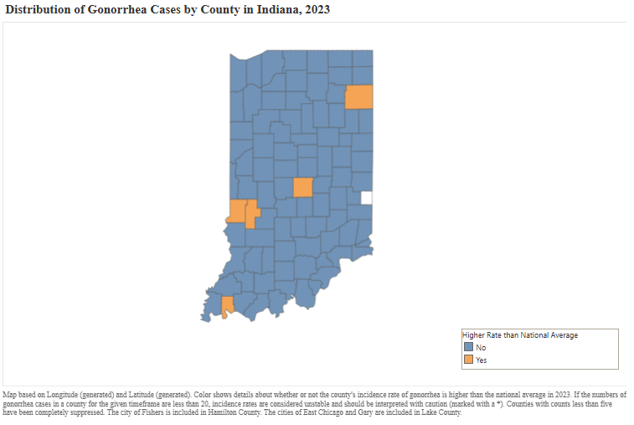
Data Source: Indiana Department of Health, STI Morbidity Rate Maps, 2023

HIV Screenings
This indicator reports the percentage of adult’s age 18-70 who self-report that they have never been screened for HIV. This indicator is relevant because engaging in preventive behaviors allows for early detection and treatment of health problems. This indicator can also highlight a lack of access to preventive care, a lack of health knowledge, insufficient provider outreach, and/or social barriers preventing utilization of services.
Data Source: Centers for Disease Control and Prevention, Behavioral Risk Factor Surveillance System. Additional data analysis by CARES. 2011-12. Source geography: County | Percent Adults Never Screened for HIV / AIDS  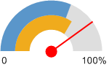  Floyd County, IN (80.04%)  Indiana (69.49%)  United States (62.79%)
  Report Area | Survey Population  (Adults Age 18 ) | Total Adults Never Screened for HIV / AIDS | Percent Adults Never Screened for HIV / AIDS
  Floyd County, IN | 40,126 | 32,116 | 80.04%
  Indiana | 4,423,475 | 3,073,751 | 69.49%
  United States | 214,984,421 | 134,999,025 | 62.79%

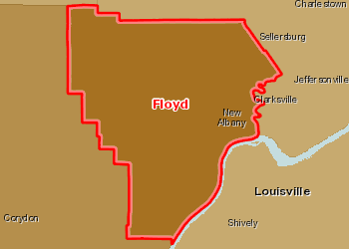 | Adults Age 18 Never Screened for HIV / AIDS, Percent by County, BRFSS 2011-12  Over 76.1%  68.1 - 76.0%  60.1 - 68.0%  Under 60.1%  No Data or Data Suppressed  Report Area

Lack of a Consistent Source of Primary Care
This indicator reports the percentage of adults aged 18 and older who self-report that they do not have at least one person who they think of as their personal doctor or health care provider. This indicator is relevant because access to regular primary care is important to preventing major health issues and emergency department visits.
Data Source: State Health Access Data Assistance Center, SHADAC analysis of Healthcare Access and Utilization, State Health Compare, SHADAC, University of Minnesota, statehealthcompare.shadac.org, Accessed 2023 and National Population by Characteristics: 2020-2024 | Percent Adults Without Any Regular Doctor  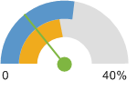  Floyd County, IN (7.82%)  Indiana (13.56%)  United States (17.15%)
  Report Area | Survey Population  (Adults Age 18) | Total Adults Without Any Regular Doctor | Percent Adults Without Any Regular Doctor
  Floyd County, IN | 63,005 | 4,924 | 7.82%
  Indiana | 5,338,189 | 723,858 | 13.56%
  United States | 266,978,268 | 45,786,773 | 17.15%

Preventable Hospital Events
This indicator reports the discharge rate (per 1,000 Medicare enrollees) for conditions that are ambulatory care sensitive (ACS). ACS conditions include pneumonia, dehydration, asthma, diabetes, and other conditions which could have been prevented if adequate primary care resources were available and accessed by those patients. This indicator is relevant because analysis of ACS discharges allows demonstrating a possible “return on investment” from interventions that reduce admissions (for example, for uninsured or Medicaid patients) through better access to primary care resources.
Data Source: Dartmouth College Institute for Health Policy Clinical Practice, Dartmouth Atlas of Health Care. 2014. Source geography: County | Preventable Hospital Events, Age-Adjusted Discharge Rate  (Per 1,000 Medicare Enrollees)  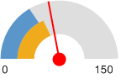  Floyd County, IN (65.9)  Indiana (57)  United States (49.9)
  Report Area | Total Medicare Part A Enrollees | Ambulatory Care Sensitive Condition Hospital Discharges | Ambulatory Care Sensitive Condition Discharge Rate
  Floyd County, IN | 8,574 | 564 | 65.9
  Indiana | 687,742 | 39,214 | 57
  United States | 29,649,023 | 1,479,545 | 49.9

Health Challenges

Tobacco Usage - Current Smokers
In the report area an estimated 15,798, or 28.1% of adults age 18 or older self-report currently smoking cigarettes some days or every day. This indicator is relevant because tobacco use is linked to leading causes of death such as cancer and cardiovascular disease.

Report Area | Total Population Age 18 + | Total Adults Regularly Smoking Cigarettes | Percent Adult Population Smoking Cigarettes
Floyd County, IN | 63,005 | 10,270 | 16.3%
Indiana | 5,338,189 | 774,037 | 14.5%
United States | 266,978,268 | 29,367,609 | 11%
Data Source: CDC, Smoking and Tobacco Use, September 2024 and National Population by Characteristics: 2020-2024

Walking or Biking to Work
This indicator reports the percentage of the population that commutes to work by either walking or riding a bicycle.  Data Source: US Census Bureau, American Community Survey. 2012-16. Source geography: Tract | Percentage Walking or Biking to Work  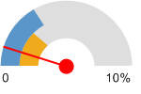  Floyd County, IN (0.98%)  Indiana (2.58%)  United States (3.37%)
  Report Area | Population Age 16 | Population Walking or Biking to Work | Percentage Walking or Biking to Work
  Floyd County, IN | 36,992 | 363 | 0.98%
  Indiana | 3,030,786 | 78,142 | 2.58%
  United States | 145,861,221 | 4,908,725 | 3.37%

High Cholesterol (Adult)
This indicator reports the percentage of adults aged 18 and older who self-report that they have ever been told by a doctor, nurse, or other health professional that they had high blood cholesterol.
Data Source: Centers for Disease Control and Prevention, Behavioral Risk Factor Surveillance System. Additional data analysis by CARES. 2011-12. Source geography: County | Percent Adults with High Cholesterol  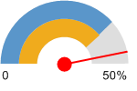  Floyd County, IN (46.80%)  Indiana (39.11%)  United States (38.52%)
  Report Area | Survey Population  (Adults Age 18 ) | Total Adults with High Cholesterol | Percent Adults with High Cholesterol
  Floyd County, IN | 40,204 | 18,818 | 46.80%
  Indiana | 3,555,280 | 1,390,393 | 39.11%
  United States | 180,861,326 | 69,662,357 | 38.52%
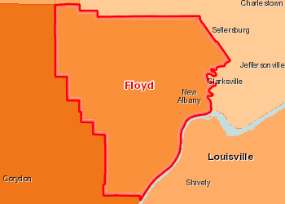 | High Cholesterol (Diagnosed), Percentage of Adults Age 18 by County, BRFSS 2011-12  Over 48.0%  42.1 - 48.0%  36.1 - 42.0%  Under 36.1%  No Data or Data Suppressed  Report Area

Mortality - Drug Poisoning
This indicator reports the rate of death due to drug overdose per 100,000 population. Figures are reported as crude rates, and as rates age-adjusted to year 2000 standard. Rates are re-summarized for report areas from county level data, only where data is available. This indicator is relevant because suicide is an indicator of poor mental health.
Data Source: Centers for Disease Control and Prevention, National Vital Statistics System. Accessed via CDC WONDER. 2012-16. Source geography: County | Overdose Death, Age-Adjusted Death Rate  (Per 100,000 Pop.)  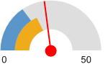  Floyd County, IN (23)  Indiana (18.84)  United States (15.6)
  Report Area | Total Population | Average Annual Deaths,  2010-2014 | Crude Death Rate  (Per 100,000 Pop.) | Age-Adjusted Death Rate  (Per 100,000 Pop.)
  Floyd County, IN | 76,295 | 17 | 22.3 | 23
  Indiana | 6,591,565 | 1,204 | 18.26 | 18.84
  United States | 318,689,254 | 49,715 | 15.6 | 15.6
  HP 2020 Target |  |  |  | <= 10.2
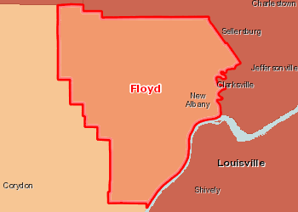 | Drug Overdose Mortality, Age Adj. Rate (Per 100,000 Pop.) by County, NVSS 2012-16  Over 25.0  20.1 - 25.0  10.1 - 20.0  Under 10.1  Data Suppressed (<20 Deaths)  Report Area

Based on the health care assessment; Floyd County has many options for primary care options, dentistry, and other medical needs. While Floyd County has higher rates of options for providers, people are not utilizing these resources available. Floyd County residents have high rates of no follow through for medical issues such as high cholesterol, high blood pressure, not getting HIV screens, and smoking but are using the Emergency Room more often than the rest of the state. As it appears that Floyd County residents do not follow through with maintaining health and dental appointments on a consistent basis, only utilizing the Emergency Room for non-emergent issues, this relates back to the struggles of meeting Head Start requirements. As Head Start and Licensing requirements for having child’s up-to-date immunizations, physical, and dental treatment (after enrollment), however, when people do not see it as a priority it is understandable as to why the parent is not following through to complete to enroll into Head Start. Based on the high rates of fast food access and low healthy food access, it is not unexpected to see high rates of medical issues as seen in Floyd County.
The Hoosier Healthwise Program is the health care program for children, low income families, and pregnant women. It is sponsored by the state of Indiana through Family and Social Services Administration. The program covers such medical care as doctor visits, prescription drugs, mental health care, dental care, hospitalizations, surgeries, and family planning at little or no cost. Most of the Floyd County Head Start and Early Head Start families participate in the program. The issue, however, for many of the families is that not all physicians and/or dentists accept the plan. The other major issue is transportation: many of the physician and dentists that do accept Hoosier Healthwise are not necessarily located to where the families live.
The main health issues for children enrolled in the program are ongoing well care, lack of physical activities outside of the school/center and parents not following up with health care needs. For adults, the main issues are the lack of care available, not following through with providers’ recommendations and the lack of insurance. Specific health issues noted by staff include: high asthma rates, increased number of children with allergies and an increase in overweight children.
Even with Hoosier Healthwise, preventive care is not a priority for Floyd County families: difficulty in getting to the medical provider, cost of taking time off from work and the culture of “if nothing’s wrong, why go to the doctor?” has contributed to this issue. Program continues to provide information and target training in this area for Head Start parents.
Immediate availability of health care is also an issue: excellent specialized care is available in Louisville but for the majority of Program families Urgent Care facilities and the emergency room at the local hospitals are where they seek immediate medical care.

Dental Health
The main dental issues for children in Floyd County Head Start service area include:
- Finding a dental home for the family
- Follow-up treatment
- Staying on dental care schedule and getting that ongoing care

For adults, the dental service issues include:
- Educating families about the importance of regular dental care: for most families dental care only happens when there is an obvious dental emergency
- Most families do not have a dental home or dental health insurance

Program staff continues to target preventive dental care as a priority: children brush their teeth every day in the classroom, parents are provided information and training about preventive dental care for themselves and their children. Staff continue to update the list of dentists who will take Medicare and/or Hoosier Healthwise and get that information to Head Start parents

Mental Health
The three main mental health issues for children in the program service area are:
- Social-emotional regulation
- Trauma
- Finding mental health care due to ages of the children

For adults the issues are:
- Social-emotional regulation
- Social stigma of accessing mental health services
- Generational cycles of mental health issues and attitudes

Although there are considerable mental health resources available in the area, both public and private, there are two main reasons that most Head Start families do not access these services.
One reason is that changes in both Hoosier Healthwise and in Medicaid have made it less likely that the services will be covered or, in the case of private providers, that the provider will accept these public programs for payment.
The Program continues to have the challenge of overcoming prejudice in the community about using mental health services. Many parents are not willing to have their children observed for suspected mental health issues and/or unwilling to accept referral to community mental health resources. Parent education and training continues in this area.

Lack of Social or Emotional Support
This indicator reports the percentage of adults aged 18 and older who self-report that they receive insufficient social and emotional support all or most of the time. This indicator is relevant because social and emotional support is critical for navigating the challenges of daily life as well as for good mental health. Social and emotional support is also linked to educational achievement and economic stability.  Data Source: Centers for Disease Control and Prevention, Behavioral Risk Factor Surveillance System. Accessed via the Health Indicators Warehouse. US Department of Health Human Services, Health Indicators Warehouse. 2006-12. | Percent Adults Without Adequate Social / Emotional Support  (Age-Adjusted)  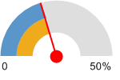  Floyd County, IN (20.3%)  Indiana (20.2%)  United States (20.7%)
  Report Area | Total Population Age 18 | Estimated Population Without Adequate Social / Emotional Support | Crude Percentage | Age-Adjusted Percentage
  Floyd County, IN | 56,220 | 11,244 | 20% | 20.3%
  Indiana | 4,848,923 | 979,482 | 20.2% | 20.2%
  United States | 232,556,016 | 48,104,656 | 20.7% | 20.7%

Nutrition
Dramatic increases in overweight and obesity have been documented among U.S. children of age, in both genders, and in all population groups. In the United States, approximately one child in five is now overweight. Overweight children are more likely to become obese adults. Additionally, an overweight school-aged child with an obese parent has over a 70% chance of being obese in young adulthood. Nationally, the Head Start Bureau has recognized this and is requesting that local Head Start programs, like Floyd County, take appropriate action steps in menu planning and parent education activities to address the problem.
SNAP and the WIC program are readily available to the Floyd County Head Start and Early families. Of the 2023-24 enrollment, 70.3% participate in SNAP and 59.9% participate in the WIC program.
Food issues identified by Program staff include:
- Scarcity of food
- Lack of transportation to be able to access full service grocery stores
- Child and adults’ lack of exposure to healthy food
The high cost of fresh fruits and vegetables coupled with the lack of high-quality grocers in some of the communities make it much more difficult for parents to provide healthy meals for their families. As a result, classroom staff report that many children have no experience eating vegetables or fresh fruits before coming to the program.
Many families with young children find it easier to pick up inexpensive fast food rather than to grocery shop for expensive fresh fruits and vegetables and take the time to cook at home. The result is diets that are high in calories and fats and low in nutrition.
Parent education and information in the nutrition area continues to be a focus of the program.

Food Insecurity - Food Insecure Children
Report Area | Population Under Age 18 | Food Insecure Children, Total | Child Food Insecurity Rate
Floyd County, IN | 17,773 | 3,830 | 21.55%
Indiana | 1,587,542 | 348,570 | 21.96%
United States | 73,580,326 | 17,284,530 | 23.49%
This indicator reports the estimated percentage of the population under age 18 that experienced food insecurity at some point during the report year. Food insecurity is the household-level economic and social condition of limited or uncertain access to adequate food.

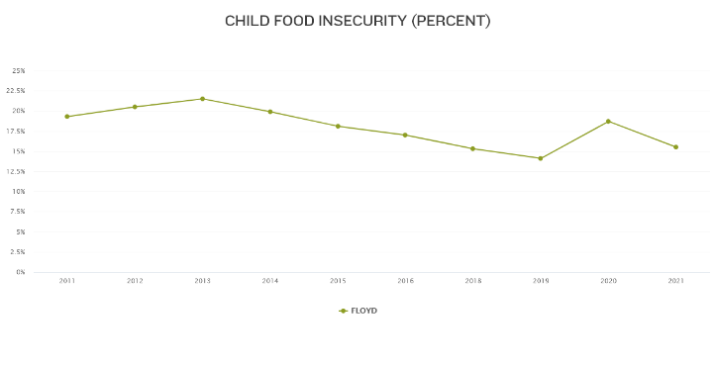

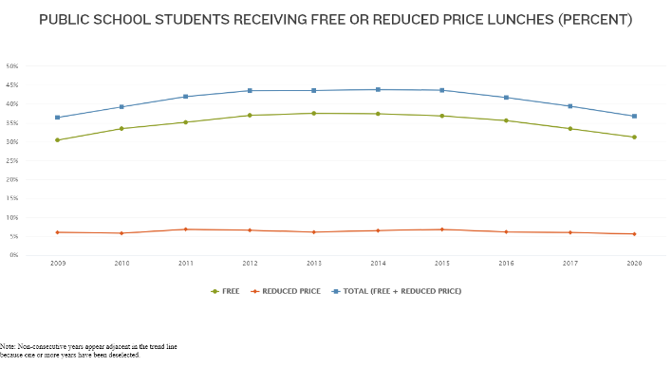

Food Insecurity - Food Insecure Population Ineligible for Assistance
This indicator reports the estimated percentage of the total population and the population under age 18 that experienced food insecurity at some point during the report year, but are ineligible for State or Federal nutrition assistance. Food insecurity is the household-level economic and social condition of limited or uncertain access to adequate food. Assistance eligibility is determined based on household income of the food insecure households relative to the maximum income-to-poverty ratio for assistance programs (SNAP, WIC, school meals, CSFP and TEFAP).
Report Area | Food Insecure Population, Total | Percentage of Food Insecure Population Ineligible for Assistance | Food Insecure Children, Total | Percentage of Food Insecure Children Ineligible for Assistance
Floyd County, IN | 10,630 | 40% | 3,830 | 37.99%
Indiana | 1,012,970 | 29% | 348,570 | 27%
United States | 48,770,990 | 29% | 17,284,530 | 31%

Food Access - Fast Food Restaurants
This indicator reports the number of fast food restaurants per 100,000 population. Fast food restaurants are defined as limited-service establishments primarily engaged in providing food services (except snack and nonalcoholic beverage bars) where patrons generally order or select items and pay before eating. This indicator is relevant because it provides a measure of healthy food access and environmental influences on dietary behaviors.
Data Source: US Census Bureau, County Business Patterns. Additional data analysis by CARES. 2015. Source geography: County | Fast Food Restaurants, Rate  (Per 100,000 Population)  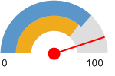  Floyd County, IN (89.84)  Indiana (72.83)  United States (74.6)
  Report Area | Total Population | Number of Establishments | Establishments, Rate per 100,000 Population
  Floyd County, IN | 74,578 | 67 | 89.84
  Indiana | 6,483,802 | 4,722 | 72.83
  United States | 312,846,570 | 233,392 | 74.6

Food Access - Food Desert Census Tracts
This indicator reports the number of neighborhoods in the report area that are within food deserts.
Report Area | Total Population (2010) | Food Desert Census Tracts | Other Census Tracts | Food Desert Population | Other Population
Floyd County, IN | 74,578 | 7 | 13 | 24,553 | 50,025
Indiana | 6,483,802 | 603 | 905 | 2,955,205 | 3,528,597
United States | 308,745,538 | 27,527 | 45,337 | 129,885,212 | 178,860,326
Data Source: US Department of Agriculture, Economic Research Service, USDA - Food Access Research Atlas. 2015.
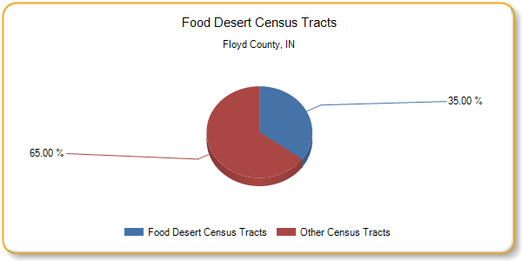

Food Access - Grocery Stores
This indicator reports the number of grocery stores per 100,000 population. Grocery stores are defined as supermarkets and smaller grocery stores primarily engaged in retailing a general line of food, such as canned and frozen foods; fresh fruits and vegetables; and fresh and prepared meats, fish, and poultry. Included are delicatessen-type establishments. Convenience stores and large general merchandise stores that also retail food, such as supercenters and warehouse club stores are excluded. This indicator is relevant because it provides a measure of healthy food access and environmental influences on dietary behaviors.
Data Source: US Census Bureau, County Business Patterns. Additional data analysis by CARES. 2015. Source geography: County | Grocery Stores, Rate  (Per 100,000 Population)  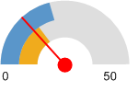  Floyd County, IN (13.41)  Indiana (15.58)  United States (21.19)
  Report Area | Total Population | Number of Establishments | Establishments, Rate per 100,000 Population
  Floyd County, IN | 74,578 | 10 | 13.41
  Indiana | 6,483,802 | 1,010 | 15.58
  United States | 312,846,570 | 66,284 | 21.19

Food Access - Low Food Access
This indicator reports the percentage of the population living in census tracts designated as food deserts. A food desert is defined as a low-income census tract (where a substantial number or share of residents has low access to a supermarket or large grocery store. This indicator is relevant because it highlights populations and geographies facing food insecurity.
Data Source: US Department of Agriculture, Economic Research Service, USDA - Food Access Research Atlas. 2015. Source geography: Tract | Percent Population with Low Food Access  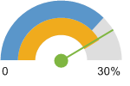  Floyd County, IN (24.8%)  Indiana (25.31%)  United States (22.43%)
  Report Area | Total Population | Population with Low Food Access | Percent Population with Low Food Access
  Floyd County, IN | 74,578 | 18,498 | 24.8%
  Indiana | 6,483,802 | 1,641,186 | 25.31%
  United States | 308,745,538 | 69,266,771 | 22.43%

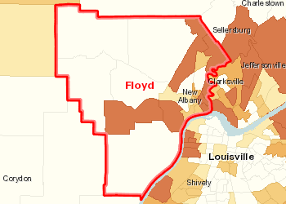 | Population with Limited Food Access, Percent by Tract, FARA 2015  Over 50.0%  20.1 - 50.0%  5.1 - 20.0%  Under 5.1%  No Low Food Access  Report Area

Food Access - Low Income with Low Food Access
Data Source: US Department of Agriculture, Economic Research Service, USDA - Food Access Research Atlas. 2015. Source geography: Tract | Percent Low Income Population with Low Food Access  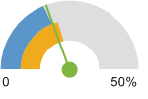  Floyd County, IN (19.55%)  Indiana (21.34%)  United States (18.94%)
  Report Area | Total Population | Low Income Population | Low Income Population with Low Food Access | Percent Low Income Population with Low Food Access
  Floyd County, IN | 74,578 | 25,305 | 4,946 | 19.55%
  Indiana | 6,483,802 | 2,285,586 | 487,790 | 21.34%
  United States | 308,745,538 | 106,758,543 | 20,221,368 | 18.94%

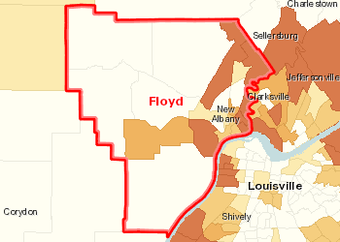 | Population with Limited Food Access, Low Income, Percent by Tract, FARA 2015  Over 50.0%  20.1 - 50.0%  5.1 - 20.0%  Under 5.1%  No Low Food Access  Report Area

Food Access - Modified Retail Food Environment Index
This indicator reports the percentage of population living in census tracts with no or low access to healthy retail food stores. Figures are based on the CDC Modified Retail Food Environment Index. For this indicator, low food access tracts are considered those with index scores of 10.0 or less.
Report Area | Total Population | Percent Population in Tracts with No Food Outlet | Percent Population in Tracts with No Healthy Food Outlet | Percent Population in Tracts with Low Healthy Food Access | Percent Population in Tracts with Moderate Healthy Food Access | Percent Population in Tracts with High Healthy Food Access
Floyd County, IN | 74,590 | 0% | 31.49% | 41.02% | 27.49% | 0%
Indiana | 6,483,792 | 1.91% | 25.2% | 22.55% | 42.06% | 8.27%
United States | 312,474,470 | 0.99% | 18.63% | 30.89% | 43.28% | 5.02%
Data Source: Centers for Disease Control and Prevention, Division of Nutrition, Physical Activity, and Obesity. 2011. Source geography: Tract

Population with Low or No Healthy Food Access, Racial Disparity Index
Report Area | Disparity Index Score  (0 = No Disparity; 1 - 15 = Some Disparity; Over 15 = High Disparity)
Floyd County, IN | 19.28
Indiana | 19.81
United States | 16.59

Population with Low or No Healthy Food Access by Race/Ethnicity, Percent
Report Area | Total Population | Non-Hispanic White | Non-Hispanic Black | Non-Hispanic Asian | Non-Hispanic American Indian / Alaska Native | Non-Hispanic Other | Multiple Race | Hispanic or Latino
Floyd County, IN | 70.23 | 72.13% | 38.33% | 68.83% | 50.38% | 59.72% | 51.4% | 59.84%
Indiana | 50.26 | 48.24% | 68.47% | 48.8% | 52.22% | 53.45% | 52.65% | 56.07%
United States | 52.02 | 49.33% | 64.15% | 51.26% | 54.56% | 57.92% | 53.64% | 54.98%
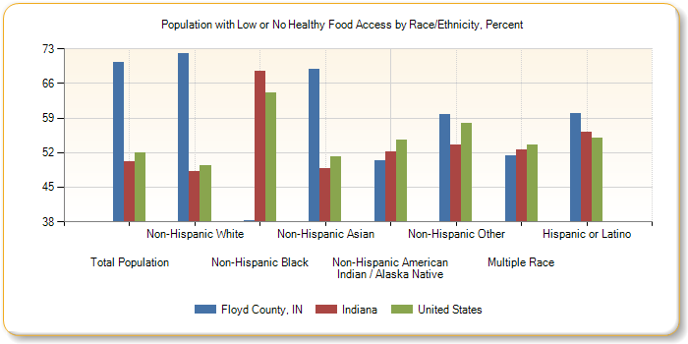

Food Access - SNAP-Authorized Food Stores
This indicator reports the number of SNAP-authorized food stores as a rate per 10,000 population. SNAP-authorized stores include grocery stores as well as supercenters, specialty food stores, and convenience stores that are authorized to accept SNAP (Supplemental Nutrition Assistance Program) benefits.  Data Source: US Department of Agriculture, Food and Nutrition Service, USDA - SNAP Retailer Locator. Additional data analysis by CARES. 2017. Source geography: Tract | SNAP-Authorized Retailers, Rate  (Per 10,000 Population)  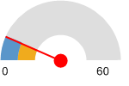  Floyd County, IN (7.91)  Indiana (8.14)  United States (8.25)
  Report Area | Total Population | Total SNAP-Authorized Retailers | SNAP-Authorized Retailers, Rate per 10,000 Population
  Floyd County, IN | 74,578 | 59 | 7.91
  Indiana | 6,483,802 | 5,280 | 8.14
  United States | 312,411,142 | 257,596 | 8.25

Food Access - WIC-Authorized Food Stores
This indicator reports the number of food stores and other retail establishments per 100,000 population that are authorized to accept WIC Program (Special Supplemental Nutrition Program for Women, Infants, and Children) benefits and that carry designated WIC foods and food categories. This indicator is relevant because it provides a measure of food security and healthy food access for women and children in poverty as well as environmental influences on dietary behaviors.
Data Source: US Department of Agriculture, Economic Research Service, USDA - Food Environment Atlas. 2011. Source geography: County | WIC-Authorized Food Stores, Rate  (Per 100,000 Population)  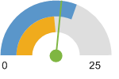  Floyd County, IN (13.3)  Indiana (12.2)  United States (15.6)
  Report Area | Total Population  (2011 Estimate) | Number WIC-Authorized Food Stores | WIC-Authorized Food Store Rate (Per 100,000 Pop.)
  Floyd County, IN | 74,990 | 10 | 13.3
  Indiana | 6,551,322 | 802 | 12.2
  United States | 318,921,538 | 50,042 | 15.6

Fruit/Vegetable Consumption
In the report area an estimated 39,366, or 71.3% of adults over the age of 18 are consuming less than 5 servings of fruits and vegetables each day. This indicator is relevant because current behaviors are determinants of future health, and because unhealthy eating habits may cause significant health issues, such as obesity and diabetes.
Data Source: Centers for Disease Control and Prevention, Behavioral Risk Factor Surveillance System. Accessed via the Health Indicators Warehouse. US Department of Health Human Services, Health Indicators Warehouse. 2005-09. Source geography: County | Percent Adults with Inadequate Fruit / Vegetable Consumption  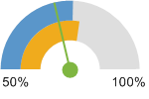  Floyd County, IN (71.3%)  Indiana (78.2%)  United States (75.7%)
  Report Area | Total Population  (Age 18 ) | Total Adults with Inadequate Fruit / Vegetable Consumption | Percent Adults with Inadequate Fruit / Vegetable Consumption
  Floyd County, IN | 55,212 | 39,366 | 71.3%
  Indiana | 4,755,941 | 3,719,146 | 78.2%
  United States | 227,279,010 | 171,972,118 | 75.7%

Physical Inactivity
Within the report area, 16,645 or 28.6% of adults aged 20 and older self-report no leisure time for activity, based on the question: "During the past month, other than your regular job, did you participate in any physical activities or exercises such as running, calisthenics, golf, gardening, or walking for exercise?". This indicator is relevant because current behaviors are determinants of future health and this indicator may illustrate a cause of significant health issues, such as obesity and poor cardiovascular health.
Data Source: Centers for Disease Control and Prevention, National Center for Chronic Disease Prevention and Health Promotion. 2013. Source geography: County | Percent Population with no Leisure Time Physical Activity  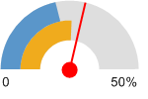  Floyd County, IN (28.6%)  Indiana (25.6%)  United States (21.8%)
  Report Area | Total Population Age 20 | Population with no Leisure Time Physical Activity | Percent Population with no Leisure Time Physical Activity
  Floyd County, IN | 56,616 | 16,645 | 28.6%
  Indiana | 4,799,070 | 1,261,851 | 25.6%
  United States | 234,207,619 | 52,147,893 | 21.8%

Adults with No Leisure-Time Physical Activity by Gender
Report Area | Total Males with No Leisure-Time Physical Activity | Percent Males with No Leisure-Time Physical Activity | Total Females with No Leisure-Time Physical Activity | Percent Females with No Leisure-Time Physical Activity
Floyd County, IN | 7,714 | 27.9% | 8,932 | 29.1%
Indiana | 572,930 | 24.2% | 688,924 | 26.89%
United States | 23,209,824 | 20.13% | 28,938,104 | 23.22%

Recreation and Fitness Facility Access
This indicator reports the number per 100,000 population of recreation and fitness facilities as defined by North American Industry Classification System (NAICS) Code 713940. This indicator is relevant because access to recreation and fitness facilities encourages physical activity and other healthy behaviors.
Data Source: US Census Bureau, County Business Patterns. Additional data analysis by CARES. 2015. Source geography: County | Recreation and Fitness Facilities, Rate  (Per 100,000 Population)  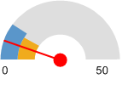  Floyd County, IN (5.36)  Indiana (9.1)  United States (10.46)
  Report Area | Total Population | Number of Establishments | Establishments, Rate per 100,000 Population
  Floyd County, IN | 74,578 | 4 | 5.36
  Indiana | 6,483,802 | 590 | 9.1
  United States | 312,846,570 | 32,712 | 10.46
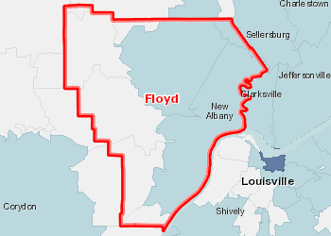 | Recreation and Fitness Facilities, Rate (Per 100,000 Pop.) by ZCTA, CBP 2015  Over 12.0  8.1 - 12.0  4.1 - 8.0  Under 4.1  No Fitness and Recreation Centers  Report Area
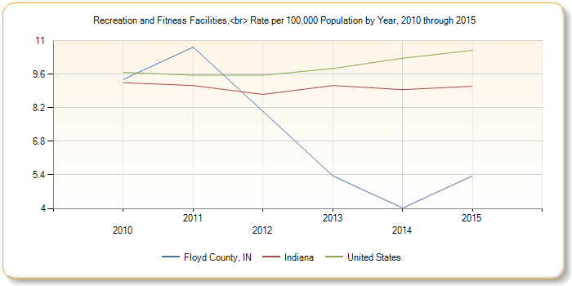
Head Start has a high level of children that are considered overweight or obese, the above factors relate back to these high numbers. Floyd County has an extremely high rate of fast food access compared to the state and national levels (90% vs 72%), lack of fitness options, and limited healthy food stores which coincides with the lower number of vegetable and fruit intake for Floyd County.

Resource Availability/Accessibility
In all area of accessing resources for services, the issue for many families is not so much the availability of resources but the accessibility of the resources. Transportation for families without a car or who only have one car and that vehicle goes to work with the commuting member of the family limits availability. For working families, the 8 to 4, Monday through Friday hours of most resources entail having to take time off from work which results in loss of income. As a result, many families do not access resources and services for which they are eligible.

Use of Public Transportation
This indicator reports the percentage of population using public transportation as their primary means of commute to work. Public transportation includes buses or trolley buses, streetcars or trolley cars, subway or elevated rails, and ferryboats.
Data Source: US Census Bureau, American Community Survey. 2012-16. Source geography: Tract | Percent Population Using Public Transit for Commute to Work  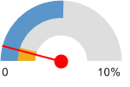  Floyd County, IN (0.82%)  Indiana (1.08%)  United States (5.13%)
  Report Area | Total Population Employed Age 16 | Population Using Public Transit for Commute to Work | Percent Population Using Public Transit for Commute to Work
  Floyd County, IN | 36,992 | 303 | 0.82%
  Indiana | 3,030,786 | 32,709 | 1.08%
  United States | 145,861,221 | 7,476,312 | 5.13%

Child Care Resources
In Indiana, Child Care Development Funds (CCDF) assist low-income families with child care expenses. To access these funds the family’s income must be at or below 150% of poverty. In addition, families must establish need for child care services because of employment, in school, or enrolled in job training. The CCDF funds are regulated and overseen by the Indiana Family and Social Service Administration, Bureau of Child Care through a network of contractors who provide the intake and eligibility services.
The Child Care Resource and Referral Agency provides families with information about child care in the area thus allowing parents the freedom to choose the type and location of the child care that best meets their needs. Building Blocks, formerly 4C of Southern Indiana is the CCR&R agency serving Floyd County.
The average cost of child care in the five county area is $7,316 per year. Despite the availability of child care in the area, the cost is too expensive for low-income families.
The CCDF fund vouchers are not always readily available: waiting lists and stringent program requirements limit accessibility. In addition, the number of available child care providers that accept child care vouchers has declined due to the increase cost of being a provider and changes in the child care licensing regulations.
It is difficult to assess the number of children who are cared for outside their own homes by relatives or in unlicensed child care. However, some parts of Floyd County have few commercial child care centers in part because there is very little demand for the service; extended families in the community care for children of working parents. The underground economy of child care continues to grow as more mothers enter the work force in jobs that do not pay enough to allow parents to pay for quality licensed child care and the lack of availability of child care vouchers.
Floyd County Head Start and Early Head Start is becoming a more viable option for child care for families. The programs’ long-term goal of expansion will provide parents with the quality child care they need to both work and keep their children in a safe, health, positive learning environment.

Child Development, Child Care Centers and Family Child Care Programs
NAFCS Pre-K Program | 80 slots
NAFCS Pre-K Early Intervention | 100 Slots Special Education Services Only
8 Licensing Child Care Centers  Includes On My Way Pre-K (76 Slots) | 594 Slots
Approximately 27 daycares in Floyd County, Indiana; including 4 home-based programs and 23 center-based programs. Average cost of daycare is $641 per month for full-time slot. Only 15 daycares accept infants including 4 home-based and 11 center-based.

Chapter 4: Strengths & Challenges

Community Strengths and Challenges
The agency collected information from a variety of sources to determine the strengths and needs of the low-income families served. Staff conducted strengths and needs surveys as part of the family partnership agreement process. Information was gathered from clients to identify the needs that were perceived to be the most pressing and staff were polled to ascertain what they perceived to be the strengths of the families served and the most pressing challenges in the county.

Community Strengths
- Access to Medical and Dental Providers
- Overall median income
- Employment Rates and Job Availability

Community Challenges
- The lack of safe, affordable, low-income housing. Vouchers are available to eligible families but not all families meet the more stringent eligibility standards. Even with a voucher not all landlords or apartment managers will rent to Section 8 clients.
- Not enough money to meet families’ needs. Despite the increase in employment and the increase in wages in the area, the increased cost of living has made it difficult for families to meet basic needs, i.e., housing, transportation, utilities, food, and clothing. This is especially true when unbudgeted events occur, e.g., illness that necessitates missing work, car break downs, unexpected health care costs. The significant increase in cost of fuel has negatively impacted the family budgets of all the Floyd County families.

- The lack of a reliable means of transportation. Public transportation does not exist in any meaningful way. Most families do have access to a vehicle but that vehicle is often shared among other family members and/or may not be in good repair. The increased cost of fuel has become a serious issue for many low-income families: the choice between paying for necessities, like utilities and rent or putting gas in the car in order to go to work, has become a no-win decision that many families are making. This is exacerbated when many have to travel considerable distances to their places of employment.

- An additional need/challenge that is facing the increasing population of Hispanic families is the lack of bilingual staff in the schools and community agencies to address their needs. The difficulty in communication for those families who do not have adequate English language skills to make their needs known often necessitates that the family bring a friend, another family member or a paid translator to the community agency or school to provide language assistance. The communication becomes stilted and, since the translators are not professional interpreters, this arrangement can often lead to more misunderstandings. In addition, forms, applications, permissions etc. are frequently not translated into Spanish.

Family Strengths & Challenges

Family Strengths
Overall, in the service area, the top three family strengths are:
- Families value their children’s education and want their children to succeed
- Families are resilient and have strong bonds with their children
- Employment has increased. That is, more parents have steady jobs or a steady source of income.
Source: 2024 PIR

Family Challenges
Overall, in the service area, the top three family challenges are:
- Consistency and Longevity in Employment
- Housing Assistance & Nutrition Education
- Emergency or Crisis Intervention (Food, Clothing, Housing)
- Assistance in enrolling into an education or job training program
- Being connected to others and supports in the community.

Chapter 5: Conclusions

Needs, Goals and Takeaways
In reviewing data from federal, state and local statistical sources; information from parents and data collected by staff, the following critical needs have been identified, strategies posited, and conclusions drawn.

Identified Needs

Need: Programs that address the low-income population and housing
Despite the fact that the families in Floyd County Head Start and Early Head Start are strong, want their children to succeed, are becoming better educated, and have the availability of community resources; structural poverty still exists because of the lack of options and opportunities for employment in jobs that pay well and have good benefits. Additionally, the decline in sufficient housing for low-income families has created even more barriers.

Need: Opportunities for lucrative employment
The numbers of Head Start parents who are in the workforce but still eligible for Head Start and/or Early Head Start, points to the need for employment opportunities in jobs that pay well. The educational achievement data show that though education level has improved there is still a need for skill-based education programs.

Need: More bi-lingual staff in the schools and community agencies to address the needs of the non-English speaking population
Although the population of non-English speaking families served by the program is still small, it is a growing population. The difficulty in communication for those families who do not have adequate English language skills to make their needs known often necessitates the family bringing a friend, another family member or a paid translator to the community agency or school to provide language assistance. The communication becomes stilted and, since the translators are not professional interpreters, this arrangement can often lead to more misunderstandings. In addition, forms, applications, permissions etc. are frequently not translated into Spanish.

Need: Affordable, high quality child care
Although there is not a dramatic need for child care slots in the area, generally, as more members of extended families enter the work place there will be a need for low cost child care and child care placements available in the low-income communities especially infant and toddler care.

Conclusions
The national political climate and more locally, the state budget concerns are impacting the funding and focus of programs that the agency has delivered in the community. Possible changes in Head Start funding, state budget reduction strategies and continued reform of social service programs will impact directly the populations the agency serves. These changes will require the agency to continue to review and analyze its systems for delivering services.
Like many in the human service sector, we are faced with declining resources and expanding needs. Only by continuous improvement of agency services and coordination of efforts with other service providers in the area will we be able to provide high quality services to our target population.
In turn, the agency must encourage other service providers to also identify their niches to ensure that duplication of services does not occur and that scarce resources are most efficiently allocated.
Partnership opportunities with others in the service area exist in the following areas:
- support of and from local business and industry to identify labor requirements and provide job readiness and training to develop an employable work force;
- collaboration with health and social services agencies to provide adequate, available and accessible health care services for the entire family,
- cooperation with secondary, vocational, and post-secondary education institutions to continue the support for dropout prevention and educational readiness for workforce entry members of the low-income community; and
- Work with area community agencies in developing capacity to serve the expanding non-English speaking population.
The agency must also assess its own programs:
- Assess the feasibility of providing additional Early Head Start services when the opportunity for funding presents itself;
- Refocus program priorities to address the needs identified through this assessment;
- Direct job readiness and training resources and appropriate agency job opportunities toward the target populations in the service area;
- Support its staff and clients in community, personal, economic and leadership development; and
- Maintain an agency workforce of qualified individuals committed to service and advocacy for the ever-changing low-income community.
The agency faces opportunities and challenges in its mission to improve the lives of low-income individuals in Floyd County. Existing successful community partnerships form a solid foundation for expanded networking and collaboration. However, uneven distribution of resources, underemployment and unemployment, and the continuing changes in the population characteristics underscore the importance of effective social programs.
Careful attention to program design, staff development, and resource allocation based on the findings of this community needs assessment will ensure that the programs and services of Floyd County Community Action Agency, Inc. thoughtfully and systematically address the needs of the area’s most vulnerable residents.

