Floyd County Head Start: Birth to Five Dental Exam
Date of Exam: ___________________________________________ Fax Completed Exam to 812-948-6989
Child’s Name: ___________________________________________ Date of Birth: _____________________
Insurance Type, Check all that apply:
Medicaid/EPSDT Head Start Pay Private Insurance Other: ______________
Purpose of Visit, Check all that apply:
Prophylaxis Cleaning Fluoride X-Rays Oral Education Treatment
Has child previously seen a dentist?: No Yes  Treatment Needed: No Yes (Restoration, pulp therapy, extraction)  If Yes:  Date of Treatment Appointment: ______/_______/ _______  Approximate Number of Visits Needed: _________________  Recall Visit Date: __________________________________ | 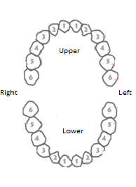 | Please mark teeth that need treatment  Comment: (Treatment Plan)
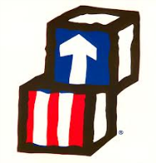
Doctor’s Printed Name: __________________________________ Doctor’s Signature: ____________________________________
Doctor’s Phone Number: __________________________________ Fax Number: _________________________________________
Floyd County Head Start: Birth to Five Dental Examinations
Attention Parents,
- Children must have a dental exam with 30 days of enrollment into the program or a dental exam appointment that can be verified. You must report all appointments to the Health Office.
- We offer financial assistance if your child does not have Medicaid/HHW or dental insurance. Please contact the Health office for a referral and an assistance letter.
- If your child had a dental exam in the last 6 months there is NO need to repeat the exam. You may take the dental exam form to the dentist for completion and return it.
- If your child does not have a dentist, listed below are dentists that work closely with Head Start.

Clarksville Dental Care 529 E. Lewis and Clark Pkwy, Clarksville (812)725-9200
*Jeffersonville Pediatric Dentistry 2929 Charlestown Pike, Jeffersonville (812)941-0588
*Kid’s Dentistree 2325 Green Valley Rd., New Albany (812)944-9300
Kidz Smile Dentistry 3120 Blackiston Mill Rd., New Albany (812)941-0008
New Albany Pediatric Dentistry 4317 Charlestown Rd, Suite 105, New Albany (812)258-9626
Family Health Center 1319 Duncan Ave., Jeffersonville (812)283-5980
*Spanish Speaking Staff
If you have any questions or concerns you can call the Health Office at (812)948-6981 ext. 1111 (Rene) or 1216 (Ashley). The Health Office fax number is 812-948-6989.
Please fill out this box for your record.
Dentist: ___________________________________ Dentist Phone Number: _______________________

Dental Exam Appointment:________________________________________________________________________

